HMA Global SOPs 2018
CHAPTER 8: MECHANICAL DEMINING

Release date: December 2018
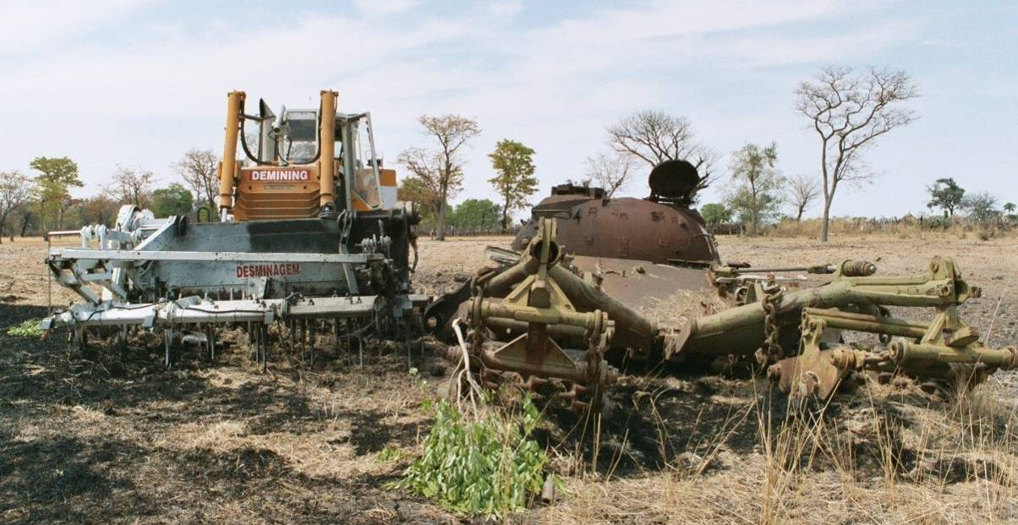
The photograph above shows two large demining machines severely damaged by AT mine blasts.
The T55 tank with its KMT5 roller system in front was abandoned after an AT mine detonated beneath it and breached the hull with fatal consequences.
The 32 ton Mine Clearance Cultivator (MCC) was severely damaged by an AT mine as it attempted to process the ground alongside the tank when this photograph was taken. The MCC was remotely controlled so no one was inside it at the time of the blast.
While both machines exposed or detonated some AT mines, they both left all the smaller AP mines and varied ordnance behind – so the entire area behind the machines still needed to be Searched & Cleared by deminers before it could be released as ‘Cleared’.
This picture illustrates two important points.
 NOTE: AT mines are designed to penetrate heavy armour and kill operators. They can severely disrupt machines designed to expose them, causing damage that costs far more than alternative, effective Search & Clearance procedures.
 NOTE: The developer’s claims for the performance of a machine must never be accepted without thorough testing.
The use of small machines such as IED robots and Small Unmanned Aircraft that are controlled by specialist deminers in HIEDC tasks is not covered in this Chapter (see Chapter 7).

CHAPTER 8: MECHANICAL DEMINING
A version of these SOPs has been available since 2007. This Chapter has been extensively changed and updated for this 2018 release. Definitions that are necessary to understand this SOP are included at the start of the Chapter.
Contents
1. Glossary 4
2. Introduction 8
2.1 Demining machines in Humanitarian Mine Action (HMA) 9
2.2 Principles 10
2.3 Speed and safety 12
2.3.1 Safety when repairing and servicing demining machines 13
2.3.2 Operator safety through armour or remote control 13
2.4 The real cost of demining machines 15
2.5 General rules for demining machines 15
2.5.1 Designated inspection area 16
2.6 Terrain categories 17
2.7 Demining machine deployment plan 17
2.7.1 Limitations of flailing machines 18
2.7.2 Limitations of ground tilling machines 19
2.7.3 Limitations of raking machines 20
2.8 Checking the depth of ground processing 21
2.8.1 Conducting QA on the depth of ground processing 22
2.9 Using demining machines for area preparation 22
2.10 Using machines to locate mined areas 22
2.11 Using machines for area verification 24
2.12 Mechanical demining teams 24
2.13 Action when a demining machine detonates an explosive hazard 25
2.14 Marking detonations and devices 25
2.14.1 Marking detonations with safe area reference points 25
2.14.2 Marking visible explosive hazards 26
2.15 When a demining machine exposes an explosive hazard 26
2.16 MEDEVAC procedures during machine use 27
2.16.1 Initial accident investigation 29
2.17 Encountering wire obstructions 29
2.18 If a machine catches fire inside the working area 30
2.19 Recovering an immobile machine 31
2.19.1 Using a recovery vehicle 31
2.19.2 Making safe access around the machine 31
3. Management of mechanical demining operations 32
3.1 Deployment limitations 32
3.2 Mechanical tasking orders 32
3.3 Mechanical demining - site requirements 32
3.4 Mechanical safety distances 33
3.5 General safety measures 33
3.6 Mechanical reporting requirements 34
3.6.1 Demining machine documentation 34
4. Using converted excavators 35
4.1 Excavator tool attachments 36
4.2 Constraints on use 36
4.2.1 General operating rules 36
4.2.2 Performance in different terrain 37
4.3 Using the rotary cutter 37
4.4 Using the excavation bucket 37
4.4.1 Searching the soil in the inspection areas 38
4.4.2 Ground preparation and vegetation cutting 39
4.4.3 Moving obstacles with the rake or bucket 39
4.4.4 Using the sifting bucket 40
4.4.5 Using the Arjun rake 40
5. The MV-4 demining flail 41
5.1 Constraints on using the MV-4 41
5.1.1 Terrain constraints for MV-4 deployment 42
5.1.2 Safety constraints 43
5.1.3 Observation posts 43
5.2 Patterns of MV-4 deployment 43
5.2.1 Overlap to ensure ground coverage 44
5.2.2 Straight line cuts 44
5.2.3 Side-to-Side passes 44
5.2.4 The snail system 45
5.2.5 Covering the same area several times 45
5.3 Deploying the MV-4 45
5.3.1 Preparing safe areas 46
5.3.2 Preparing breaches 46
5.3.3 Using the MV-4 to prepare road verges 47
5.3.4 Using the MV-4 to cut vegetation 48
6. Mine-Wolf 48
6.1 Constraints on using the Mine-Wolf 49
6.1.1 Terrain constraints for Mine-Wolf deployment 50
6.1.2 Safety constraints 51
6.2 Mine-Wolf deployment patterns 51
6.2.1 Side-step deployment 51
6.2.2 Turning inside the task area 52
6.2.3 The Snail system 52
6.2.4 The ‘U-Turn System’ 54
6.3 Mine-Wolf processing roads 55
6.4 Mine-Wolf processing verges 55
6.5 Processing the same area several times 56
7. Mine Protected Vehicles (MPVs) 56
7.1 MPV with VMMD array 57
Annex A: Risks associated with demining machines 58

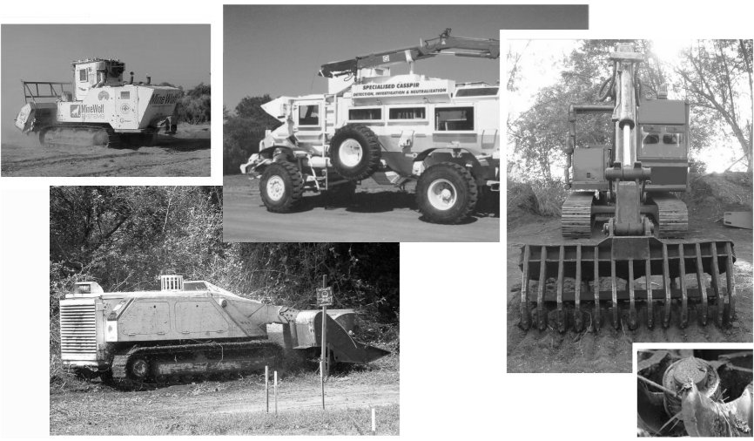
- Glossary
The following definitions are used throughout these SOPs. The use of these terms allows internal consistency and clarity in an occupation that has become complicated by the use of contradictory terms as the HMA industry has developed.
Accident (Demining accident): following ordinary use of the term, an HMA ‘accident’ is any damaging or injurious event that occurs during working hours. This includes road traffic accidents and other events that give rise to injury which do not involve explosive hazards. Whenever an accident involving explosive hazards occurs (whether injurious or not), a detailed and objective accident report must be compiled and shared. Demining accident reports must be appended to the Field Risk Register and the appropriate risk mitigation strategies recorded. See also the entry for ‘Incident (demining incident)’.
Area Cleared: the area ‘Cleared’ is a defined area (or areas) that has been subjected to one or more demining Search & Clearance procedure(s) which guarantee(s) that a thorough search to the required depth has been conducted over the entire area(s). In all areas released as ‘Cleared’, the task supervisors must have full confidence that no explosive hazards remain to the specified search depth and must be prepared to demonstrate their confidence by walking or driving over the area. When no explosive hazards are located during Search & Clearance of an area, the area may still be released as ‘Cleared’ even though there were no explosive hazards to ‘Clear’.
Area preparation: ‘area preparation’ involves the passage of a tool over a wide area to remove vegetation and/or prepare the ground surface before other demining procedures are conducted. The processing tool is generally attached to a machine that is suitably protected so that it can be safely driven over the area (often by remote control). Depending on need, the reliable depth of any ground processing may be important but is not critical because a ground engaging machine must always be followed by thorough Search & Clearance procedures if the land is to be released as ‘Cleared’.
BAC - Battle-Area-Clearance: ‘BAC’ is a visual search process that raises confidence that an area is free from explosive hazards on the ground surface without applying any subsurface search procedures. BAC cannot be used where the Task Assessment determines that there may be any buried explosive hazards that are pressure or movement sensitive. When there may be any other buried explosive hazards (such as common AXO and UXO), BAC must be followed with a reliable sub-surface Search & Clearance procedure. Areas subjected to BAC may be recorded as ‘Surface Cleared’.
BACS – Battle-Area-Clearance Subsurface: ‘BACS’ is a search process involving the use of metal-detectors that raises confidence that an area is free from explosive hazards without applying procedures that would locate hazards with a small metal content. BACS cannot be used where the Task Assessment determines that there may be any anti-personnel mines, pressure or movement sensitive devices, or buried minimum-metal explosive hazards. The metal-detectors used must be able to reliably locate all of the anticipated hazards in the area. When used as described, areas subjected to formal BACS procedures may be recorded as having been ‘Cleared of hazards with a large metal content to a specified depth’.
Clear (Presumed Clear): when applied to land, the word ‘Clear’ is used to describe land where there is no evidence of there being any explosive hazards (No Threat Evidence, NTE). When this is a result of the explosive hazards having been removed/destroyed during Search & Clearance, the area must be described as having been ‘Cleared’. When land has been released by area Reduction, Verification or Cancellation, it has not been ‘Cleared’ but can be ‘Presumed Clear’ because there is no evidence of it being likely to be contaminated with explosive hazards (No Threat Evidence, NTE). The distinction between the use of ‘Presumed Clear’ and ‘Cleared’ is important because it can be critical in cases of litigation.
Clearance: ‘clearance’ is the removal or destruction of explosive hazards. Most in the industry describe what they do as ‘clearance’. In fact what most field people are doing most of the time is preparing ground and searching. If there are no explosive hazards there, there is nothing to be ‘cleared’ so clearance cannot be happening. In these SOPs, the activity of searching for and removing or destroying explosive hazards is referred to as Search & Clearance despite the fact that, at some times, no hazards will be found and no ‘clearance’ will be required.
Cleared (land): ‘cleared land’ is a defined and mapped area that has been formally searched to a required depth and on which all explosive hazards have been removed or destroyed. An area can only be declared ‘Cleared’ after it has been subjected to disciplined Search & Clearance procedures that ensure the discovery and removal of all explosive hazards to a specified depth over the entire area. That depth must be determined during the Task Assessment and should be varied if devices are discovered at greater depths as work at the task progresses. If the depth that can be reliably searched using any one demining procedure is less than the requirement, additional search procedures must be used to gain confidence that thorough Search & Clearance to the required depth has been achieved before the area can be declared ‘Cleared’. Following Quality Management principles in pursuit of efficient Land Release, if no explosive hazards are found, an investigation should be made into why the task documentation indicated that the area was contaminated with explosive hazards when it was not.
Deminer (Searcher): a ‘deminer’ is a person engaged in Search & Clearance tasks in areas that may be contaminated with explosive hazards. A deminer must always be trained and qualified to carry our procedures related to searching. A deminer may also have EOD training, but does not have to be trained to appraise and manage the explosive hazards that are found. Persons with EOD training are called ‘EOD specialists’ and must also be trained as deminers/searchers.
Demining procedure(s): see the entry for ‘procedure’.
Demining task: see the entry for ‘task’.
Device(s): the term ‘device’ is sometimes used to describe any explosive hazard.
Explosive hazard: the term ‘explosive hazard’ is used to describe mines and ordnance whether fuzed, fired or otherwise, and all explosive devices whether mass-produced or improvised. It also covers hazardous parts of these devices, including detonators, propellants and pyrotechnics. Following the usage in international treaties and conventions, the IMAS distinguish between ‘mines’, ‘submunitions’ and ‘Explosive Remnants of War’ (ERW) and treats them separately. This is confusing because, in normal language, ‘mines’ and ‘submunitions’ are also ‘ERW’. Rather than trying to reclaim the commonsense meaning of ERW, the term ‘explosive hazard’ is used in these SOPs.
High Probability Area (HPA): a ‘High Probability Area’ is a part of a task where there is a high probability that explosive hazards are present. This may be called a Confirmed Hazardous Area or CHA by other agencies. The threat in a High Probability Area is the same as that in a Low Probability Area when the same explosive hazards may be present. Typical HPA include mapped and marked minefields, areas where mines are visible, defensive positions, areas where there have been multiple explosive accidents, and areas where the presence of hazards has been reliably reported.
Incident (Demining incident): avoiding the confusion between ‘accident’ and ‘incident’ apparent in the IMAS, in these SOPs a ‘demining incident’ is the discovery of one or more explosive hazard(s) on land that has been declared ‘Cleared’ or ‘Presumed Clear’ and released to the end-users as part of Land Release. The rigorous and honest investigation of demining incidents is necessary to ensure that errors are identified and corrected in pursuit of the primary goal of HMA. Demining incident reports must be appended to the Field Risk Register and the appropriate risk mitigation strategies recorded. See also the entry for ‘Accident (demining accident)’.
Land release, releasing land: land that is designated a task area may only be ‘released’ after either being declared ‘Cleared’ or ‘Presumed Clear’. An entire task, or parts of the task area, can be released as ‘Searched & Cleared’, ‘Reduced’, ‘Verified’, or ‘Cancelled’ (see Chapter 3 for detailed explanations of these terms).
- Land that is ‘Searched & Cleared’ of all explosive hazards to a known depth is declared ‘Cleared’.
- Land that is ‘Reduced’ by processes that result in confidence that thorough ‘Search & Clearance’ is not necessary because there is No Threat Evidence (NTE) in the area can be declared ‘Presumed Clear’.
- Land that is ‘Verified’ as having NTE in the area can be declared ‘Presumed Clear’.
- Land that is ‘Cancelled’ as having NTE in the area can be declared ‘Presumed Clear’.
Low Probability Area (LPA): a ‘Low Probability Area’ is a part or parts of the task where it is possible that there are explosive hazards but there is not enough evidence of their presence to make it probable. Typically, land bordering a High Probability Area is a Low Probability Area. The threat in a Low Probability Area is the same as that in a High Probability Area when the same explosive hazards may be present.
No Threat Evidence (NTE): any land that is not suspected of being contaminated with explosive hazards presents ‘No Threat Evidence’ (NTE) because there is no evidence that there may be explosive hazards there. The term should also be applied to any part of a task area where, after a Technical Survey and/or during subsequent demining activity there is found to be no evidence of the presence of explosive hazards. Areas processed using proven Search & Clearance procedures during a Technical Survey may be recorded as ‘Cleared’. Parts of a task that are Reduced, Verified or Cancelled as a result of demining activity must be recorded as presenting No Threat Evidence, so ‘Presumed Clear’.
National Mine Action Authority (NMAA): the NMAA is the national organisation mandated by the national government to control and monitor humanitarian mine action activities.
Presumed Clear: See the definition for ‘clear’.
Procedure(s), demining procedure(s): ‘demining procedures’ are activities conducted on land that may be contaminated with explosive hazards as part of preparing it for land release. Searching with metal-detectors or MDDs are demining procedures. Cutting undergrowth or ground processing with a demining machine are also demining procedures. One or more procedure can be applied to process the same ground to give confidence that the area can be released. Not all procedures, or combinations of procedures, constitute full Search & Clearance and so guarantee that no explosive hazards remain to the required depth in the area. This is not important when there is found to be No Threat Evidence in an area and it can be reliably ‘Presumed Clear’.
Releasing land: land that is designated a task area may only be ‘released’ after either being declared ‘Cleared’ or ‘Presumed Clear’. An entire task, or parts of the task area, can be released as ‘Searched & Cleared’, ‘Reduced’, ‘Verified’, or ‘Cancelled’ (see Chapter 3 for explanations of these terms).
Safety distance: the ‘safety distance’ is the distance at which all staff must be from a deliberate detonation in order to avoid injury. This is also the distance at which staff must be from a demining procedure that may predictably detonate some devices (such as processing the ground surface using a machine). See also the entry for ‘working distances’.
Search & Clearance (Searched & Cleared): ‘Search & Clearance’ refers to the disciplined use of demining procedures that are reliably able to locate all anticipated explosive hazards to a specified depth beneath the ground surface and the removal/destruction of those hazards over an entire recorded area. Only areas that have been Searched & Cleared can be released as ‘Cleared’.
Search depth: the ‘search depth’ is the depth beneath the ground surface to which reliable search for explosive hazards must be conducted. Unless otherwise directed by the NMAA or client, the search depth should be agreed during task planning and must be increased as soon as any evidence suggests that the hazards may be at a greater depth than was originally believed.
Searcher: See the entry for ‘Deminer’.
Suspected Hazardous Area (SHA): at the start of a demining task, the entire task area is often referred to as a ‘Suspected Hazardous Area (SHA)’. After a Technical Survey has been conducted and more becomes known as the task progresses, parts of the SHA should be designated Low Probability Areas (LPA) and High Probability Areas (HPA) where the ‘probability’ refers to the probable presence of explosive hazards. HPA and LPA designations and the Task Release Plan should be reviewed and revised as soon as more as soon as more evidence about the contamination in the SHA is gathered. As areas with No Threat Evidence are identified, they may be Reduced, Verified or Cancelled, as appropriate.
Task (demining task): a ‘task’ is a specified area of land on which a demining organisation must conduct activities detailed in a Task Release Plan in order to declare the area ‘Cleared’ or ‘Presumed Clear’ in preparation for land release.
Task site (demining task site): a demining ‘task site’ is any place where some or all of the ground is processed to find mines and/or explosive hazards in preparation for land release. The perimeter of the task site must be accurately recorded on the task map and on the ground whenever practicable. When a task is linear (as with routes), the perimeter may be marked and recorded as work progresses.
Task Folder: the NMAA (or other authority) should provide a ‘Task Folder’ containing all relevant survey data about the task being undertaken. Information gathered during this organisation’s internal Task Assessment will be added to the Task Folder to allow an informed Task Risk Assessment to be made. The Task Folder and the Task Assessment also provide an evidence base on which to make a preliminary Task Release Plan. The Task Folder may include agreements about the demining assets and procedures that must be used at the task.
Task Release Plan: the ‘Task Release Plan’ is the schedule of all demining activities that will take place in a demining task area. It includes maps of HPA and LPA showing all areas that will be released as ‘Cleared’, Reduced, Verified or Cancelled. All Task Release Plans should be revised regularly as work progresses and more becomes known about the task area. This is essential to allow the work to be conducted efficiently, so protecting the donor/client from unnecessary costs.
Task Risk Assessment (TRA): a ‘Task Risk Assessment’ is a process designed to evaluate and manage risk before and during field tasks. A TRA takes account of all available information about conditions in the task area, the hazards present and the demining procedures that are available to be used. As work at the task progresses and more information becomes available, the TRA must be revised so that the work is always conducted in a manner that minimises the main risks during HMA field activities. The main risks are the risk of leaving explosive hazards in areas that will be released (demining incidents) and the risk of demining staff suffering explosive related injury (demining accidents).
Tolerable Risk: a ‘tolerable risk’ is the risk remaining after having taken all reasonable measures to avoid the risk event and/or to minimise its undesirable consequences. The International Standards Organization (ISO) and the IMAS define ‘tolerable risk’ as “risk which is accepted in a given context based on current values of society”. Every industry is intended to interpret that definition appropriately to reflect their working context. It would be inappropriate to adopt the high-risk mindset that may prevail in a post-conflict context because the current humanitarian values in peaceful and secure societies are the values of HMA and of those paying for the work. These are also the values that will be used to define what is ‘tolerable’ during any litigation that may follow accidents or incidents.
Wide-area: in these SOPs, the term ‘wide-area’ is used to describe large land areas over which Search & Clearance will be conducted. The breach lanes that are ‘Cleared’ during a Technical Survey are not conducted over wide-areas, but parallel breaches can be combined to provide wide-area Search & Clearance.
Working distance: the ‘working distance’ should make it unlikely that more than one person will be injured in a demining accident. Working distances can generally be shorter than safety distances because demining accidents are rare and injuries to a second worker rarer still. Reduced working distances can increase safety by improving the ease of supervision which ensures that procedures are conducted correctly and risks are appropriately managed. See also the entry for ‘safety distances’.
Should, Must & Shall
Throughout these SOPs the distinction between the terms ‘should’ and ‘shall’ that is used by the International Standards Organisation (ISO) and in the International Mine Action Standards (IMAS) is adopted.
When ‘shall’ or ‘must’ is used, everyone working to these SOPs must comply with the requirements as they are written. No variation is permitted.
When ‘should’ is used, everyone working to these SOPs must follow the requirements unless they have a reason to vary them that has been approved by the senior staff with operational responsibility. Variations must be recorded in writing in the Task Release Plan and the person(s) making the variation must be identified.

- Introduction
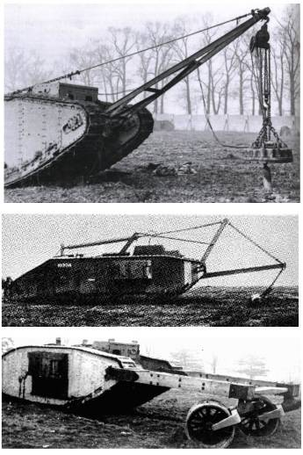
Demining machines have been used for more than 100 years. The pictures on the right show early tanks adapted for demining in WW1 and WW2. They were used to make a path for themselves to drive over and for others to follow during combat.
A machine designed for military use only has to detonate or disrupt enough hazards to make it relatively safe for others to follow. In combat situations, leaving munitions and damaged or broken explosive hazards behind is acceptable, and taking a few casualties can be tolerable.
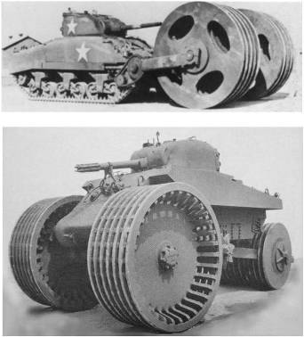
A variety of demining machines are used in HMA today and some people think that they can clear ground because the manufacturers often call them ‘Clearance machines’. ‘Clearance is defined in the IMAS as meaning that all explosive hazards are removed to a specified depth: there is no ground engaging machine that can be driven over an area and achieve this reliably.
Machines that lift the ground and then sift it before deminers search the sifted content can lead to the ground being free from explosive hazards but in this case the Search & Clearance is actually done manually. Comparing the cost of the machine and the cost of manual demining, sifting a wide area of ground would usually be slower and more expensive that it would be to Search & Clear the ground manually and it can also have devastating environmental consequences. The use of excavators and sifters in areas where
the risk to deminers is high (such as trenches, ditches and ruined buildings) can be an efficient way to keep risk tolerable while limiting environmental damage.
Demining machines cannot reliably detonate all pressure-operated devices and stand little chance of detonating devices with pins that must be pulled or of disrupting common hazards such as mortar bombs and grenades. On uneven ground, all ground processing machines can fail to process the ground to a constant depth, and so may miss buried hazards altogether. They may also leave explosive hazards damaged and in a more sensitive condition than they were before the machine was used. Making multiple passes over the ground with the same mechanical tool does not necessarily increase the probability of hazards detonating because if the tool failed to detonate a hazard on its first pass, it may well fail to do so in a dozen passes. Also, mechanically disrupting mine patterns can be a disadvantage because (by spreading the hazards) the machine can increase the area that must be Searched & Cleared after the machine has been used.
The use of any demining machine to increase speed while increasing risk to the end-users of the land, or to staff, contradicts the goals of HMA and is not permitted. Proposed machines must be considered with reference to the hazards expected where they will be used, any dangers inherent in their use, and the real cost of their deployment.
The performance claims made for many machines are misleading and the manufacturer’s recommendations for their use are often so inappropriate that their application would be entirely ineffective and contradict the primary goal of humanitarian mine action. Test results obtained in ideal conditions are seldom if ever replicated in real use. The use of all demining machines must be planned using unbiased data collected during objective trials that are conducted to determine the limitations of the demining machine.
Unbiased assessment of the machine’s limitations would have prevented, for example, the use of a rotating mine comb on packed earth roads. Where tree roots passed under the road, they tangled in the rake tines, preventing rotation and causing damage. The presence of rocks or bedrock either caused mechanical damage or meant that the depth processed had to be reduced. In sandy soil areas with no rocks or roots, the ground was reduced to a deep drift of fine dust that vehicles were unable to pass through.
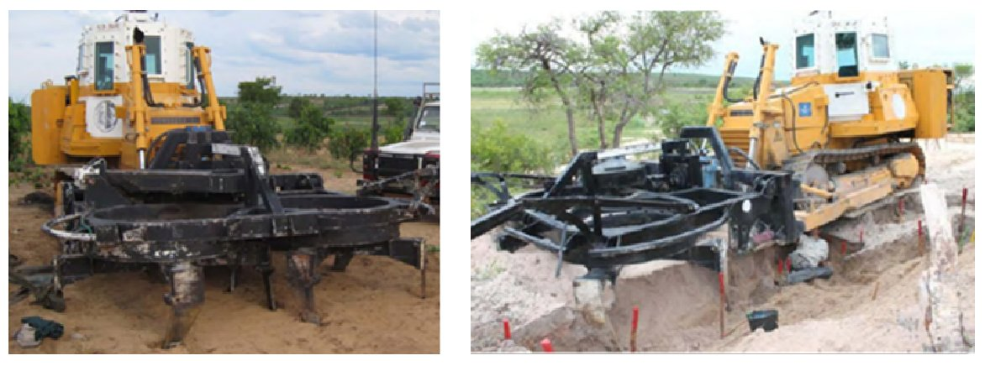
All UXO and small explosive hazards were left in the dust and larger hazards may have simply been moved around under the surface. Meanwhile, vehicles were obliged to leave the road and drive over the ground alongside, through which a mine-belt passed and accidents occurred. The use of the machine was ineffective at removing all explosive hazards, increased risk to civilians and increased the cost of Search & Clearance. Called a ‘Road Threat Reduction’ machine, its use with full Search & Clearance follow-up might have left a cleared road if it were not for the fact that the deep dust meant that minimum-metal anti-tank mines were too deep to be detected. The fact that the road could not be traversed by civilian vehicles after the rotary plough was used meant that the donor’s money was entirely wasted.
The apparent cost-effectiveness of many large, ground engaging demining machines is often shown to be illusory when it is recognised that the land will still need to be Searched & Cleared after the machine has been used. However, low-cost demining machines can be cost effective and increase the speed with which land is released dramatically when their use is sensibly integrated with true Search & Clearance procedures.

Demining machines in Humanitarian Mine Action (HMA)
Machines are used in HMA for two main reasons. The first is to enhance the safety of demining staff, and the second is to increase the speed with which land can be released. In the absence of any required minimum competencies for persons using demining machines in the IMAS, the onus falls on each organisation to ensure that their training and deployment is beyond reproach.
This Chapter covers the use of a limited range of machines. It must be extended when any machine not covered is to be used inside a potentially hazardous area. To apply each machine appropriately, all staff involved in conducting a Task Assessment must know the machine’s optimal operating conditions, its limitations and its deployment constraints. This will allow the task planners to select the appropriate machine or combinations of machines and tools to ensure the most effective outcome.
The machines covered in this Chapter are listed below.
- Converted excavator and bespoke attachment tools.
- MV-4 Mini-flail.
- Mine-Wolf with flail and tiller.
- Mine Protected Vehicles (MPVs) and MPV with detector array.
Mechanical demining is the use of machines inside a potentially hazardous area during demining operations. It may involve a single machine employing one tool, a single machine using a variety of tools or a number of machines employing a variety of tools.
Demining machines with a proven value are used for area preparation and/or to provide armoured protection to staff.
Area preparation machines include machines that are primarily designed to improve the efficiency of demining operations by reducing or removing vegetation, exposing hazards or preparing the ground surface. In some instances, they may move the ground surface for Search & Clearance in another place. Area preparation machines may detonate some hazards but are not designed with the intention of destroying all explosive hazards. Machines whose design purpose is to disturb the ground to a set depth and destroy all explosive hazards using a rotating tiller tool, flail, or variant do not achieve their design purpose but can be used in preparing breaches or wide areas when appropriate.
Mine Protected Vehicles (MPV) – vehicles specifically designed to protect the occupants from the effects of a mine detonation. When fitted with suitable wheels, these may be used to attempt to find some hazardous areas by detonating pressure activated or movement sensitive hazards under the steel wheels but this is not reliable, so not generally approved. MPVs may also be fitted with a large metal-detector array mounted on the front or the back. The signals identified by the detection system must be pinpointed and investigated using manual Search & Clearance procedure. With current technology, their value is severely limited and they should not be used unless a machine is available at no/low cost.
Demining machines can be used to:
- remove vegetation before manual or MDD search;
- prepare ground for manual Search & Clearance;
- help locate hazardous areas by detonating one or more pressure activated or movement sensitive hazard in an area;
- excavate ground and move it to be searched in another place; and
- raise the confidence of end-users of land where there is No Threat Evidence (NTE) so true Search & Clearance efforts are not required.
Generally, when a hazard has been detonated, the demining machine should not be used to deliberately detonate others in that area. This is because the machine will disrupt any pattern that is present and may scatter or bury hazards in a way that adds to deminer risk and increases the time spent in manual Search & Clearance. The demining machine may be used to approach the suspected hazardous area in other places to try to confirm the direction and extent of any pattern of pressure/movement sensitive hazards present.
 NOTE: If there are no detonations using a demining machine, that is not evidence that the land is free from explosive hazards.
See Chapter 3, Land Release, for detailed information about the way in which demining machines may be used to help prepare land for release.

Principles
Because, at any task, a demining machine may leave mines and explosive hazards damaged and in a more sensitive condition than they were before the machine was used, the following principles for the use of demining machines must be applied.
- Ground processed by all machines will not be recorded as ‘Cleared’ without appropriate follow up by manual Search & Clearance procedures. A machine can prepare the ground. The manual and/or MDD assets Search & Clear the ground. This is true even when ground is mechanically lifted and sifted because the sifted material is manually Searched & Cleared.
- Ground processed by a machine and then Searched & Cleared may be subsequently released as ‘Cleared’ or reduced as ‘Presumed Clear’ depending on the extent of the follow up Search & Clearance procedures used. Rules covering the requirements for area Reduction are given in Chapter 3 in these SOPs.
- When land is ready for release but the end-user lacks confidence in the land, the land may be processed by a machine in order to build end-user confidence. This process is called Verification (verifying that there is NTE, so no need to Search & Clear the area). Procedures for area Verification are detailed in Chapter 3 of these SOPs.
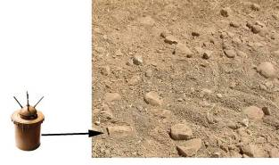
- No one should walk in the tracks left by a machine inside a task area unless the Task Release Plan indicates that no pressure, touch, or movement sensitive hazards are present. Even then, anyone walking in the tracks must search the area visually as they step forward. The machine must be standing still with its processing tool stationary before any approach is made.
This photograph on the right shows the chevron tracks
left by a large demining flail. On the bottom left is a V69
bounding fragmentation mine lying on its side. This mine
was crushed into the ground but its tilt-sensitive
fuze was still attached. There have been
recorded demining accidents after flails
have thrown mines into the air and they
have landed on ground presumed safe,
including landing directly behind the
machine. When the ground is dry, the entire area
processed by a flail can become coated with dust and
mines and explosive hazards on the surface can be difficult to see.
- The use of machines must increase efficiency at a task. To achieve this, the Task Release Plan should detail how and when the machine will be needed. The task supervisor should liaise with the mechanical team leader to ensure that the Task Release Plan is compatible with the tasking orders for the mechanical demining team.
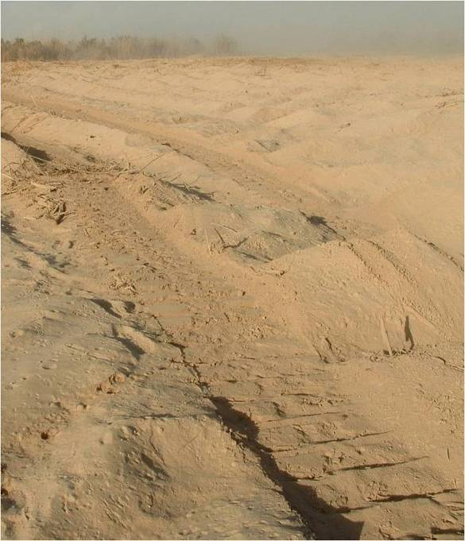
- The use of the machine should not cause
unnecessary environmental damage. Flails and tillers commonly do this by destroying root systems and leaving land that is vulnerable to wind and water erosion.
The picture on the right shows ground that was
seasonal pasture land before the machine was used. The entire ground surface has been reduced to fine dust which is rapidly blowing away. Even if the machine had been able to make the land explosive hazard free (which it was not), destroying the land’s usefulness in the process is of no value to the end-users and contradicts the stated goals of HMA.

Speed and safety
Demining machines that remove vegetation and/or process the ground in front of manual or MDD Search & Clearance can increase speed and safety in several ways but these advantages rely on the machine being used in the approved way.
It is often not necessary to try to maintain a regular depth beneath the ground surface that is being prepared for two reasons. First, because it is usually impossible to do so. Second, because it is not necessary to do more than process the ground surface unless AT mines or similar hazards are present. When AT mines of similar hazards are anticipated, processing the ground to a depth of 30cm can make it less likely that the demining machine will detonate a hazard beneath its tracks or wheels. However, the risk of damage to the ground processing tool is increased, so the deliberate use of demining machines in areas where large pressure or movement sensitive explosive hazards are known to be present is not permitted.
Tests should be made to determine whether the ground processing may push any of the anticipated explosive hazards deeper beneath the original ground surface in the ground conditions in each working area. When the results indicate that this may occur, the depth of processing must be limited to avoid any risk of explosive hazards being pushed down because this can make subsequent Search & Clearance more hazardous and increase the risk of leaving hazards behind.
When using any machines that were originally designed for civil use, tests should be conducted to determine the level of damage likely to result from the detonation of the smaller anticipated explosive hazards (such as anti-personnel blast mines) under its wheels or tracks. The picture below shows steel tracks after the detonation of PMN-2 AP blast mines. The cost of repair was too high for the use of the machine to be continued.
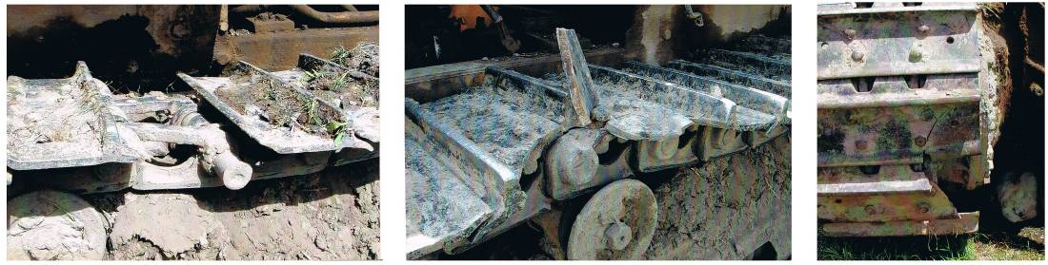
Some advantages of using demining machines are listed below.
- Where there are tripwires or devices with tilt-activated fuzes, the use of a machine can reliably break any intact tripwires and can break or initiate some of the fuzes.
- When pressure activated mines are laid in part of the area in predictable patterns, the use of a machine may detonate some mines and so help to indicate High Probability Areas (HPA), but this can never be guaranteed. The use of any ground engaging machine inside a mine pattern is not permitted because the pattern will be disrupted and subsequent Search & Clearance may need to be conducted over a much wider area.
- Where there is vegetation, some machines can cut the vegetation and make it easier for the task to be assessed and for Search & Clearance procedures to be conducted where appropriate.
- When the ground is hard, a machine can break up the first few centimetres of the ground surface in a way that significantly increases the speed with which deminers can use manual procedures after the machine has passed. There is evidence that the frustrations caused by demining in hard ground causes accidents, so preparing the ground with a machine can make the deminer’s task both faster and safer as long as the process does not destroy the ecology of the area.
When machines are used improperly, their use can lead to an intolerable reduction in safety.
- If mechanically prepared ground is declared ‘Cleared’ or NTE without any follow-up Search & Clearance, the safety of the end-users of the land will be reduced in a way that conflicts with the primary goal of HMA. This shall not be permitted. Mechanically prepared ground may be followed by wide-area Search & Clearance, area Reduction procedures or Cancelled when the appropriate land release criteria described in Chapter 3 are met.
- Machines must not be used to detonate mines in a patterned minefield. If they are used for this, the precise position of each detonation cannot be recorded and it is usually impossible to know how many mines have been detonated/disrupted. Evidence of any mines that may have migrated out of the pattern is lost along with evidence of the relatively small areas that they may have moved into. The mechanically processed area must be manually searched for the explosive hazards that the machine missed, or could not initiate, and then the entire area surrounding the original pattern must also be searched for missing mines. True Search & Clearance of a patterned minefield is generally safer, cheaper and faster without first using a machine to try to detonate what it can.
- Deminers conducting Search & Clearance procedures following a machine must be trained in how to approach the kind of damaged and disrupted explosive hazards that may be found.
- Deminers may rely on the demining machine to have prepared all of the area as intended. Machine operators should ensure that the entire working area is prepared and no areas are missed except when necessary, as when working close to, or around, an obstacle. When the ground preparation raises a lot of dust, it can be impossible to see which areas have been processed and which have not, so the machine operator should make a reliable map showing areas where the machine has worked and where it has not worked.

Safety when repairing and servicing demining machines
Mechanics should only work on demining machines for which they have had training and should only conduct procedures in accordance with the manufacturer’s instructions and those variations that have been approved and documented by the organisation’s Operations Manager.
The training of mechanics must stress the following general safety concerns. These concerns are entirely based on experience:
- Mechanics must not work on machines with high-pressure hydraulic systems while the engine is running.
- The battery must be disconnected before working on any electrical system.
- The alternator must always be disconnected before any electric arc-welding is conducted.
- When machines or parts of machines are held suspended in the air, no one should work or stand beneath the suspended part(s) until they have been securely supported.
- Persons must not use their fingers to align holes in heavy parts.
Mechanics should have the relevant manufacturers’ handbooks available at all times.

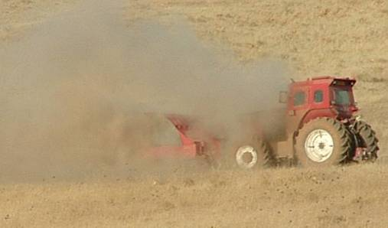
Operator safety through armour or remote control
Demining machines may be operated by a person inside the machine or may be remotely controlled by an operator(s) at a distance. A few manufacturers offer machines that can be controlled either way but this combines the expense of heavy armouring to protect an operator and the high cost of a remote control system, so should generally be avoided.

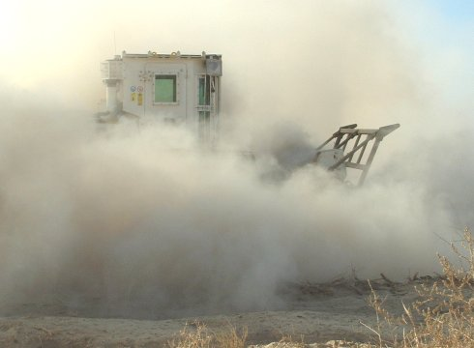
When the operator is inside the machine, the machine must be armoured to provide appropriate protection. This can be hard to achieve when the machine must be designed to cope with all possible explosive hazards, including hazards with an armour-piercing capability. As a result, the operator is often positioned at the back of the machine with a heavy armoured shield between the ground engaging tool and the operator’s armoured cabin. This means that the on-board operator is unable to see the ground engaging parts of the machine. When the tool raises dust, as shown in the photographs of flail machines, the operator is often entirely unable to see where the machine is going. External observers have to guide the operator by radio or telephone, so the machine is effectively remotely controlled. In these circumstances, there is no advantage in having a human operator inside the machine. The cost and weight of the armouring required to protect the operator is unnecessary.
Efficient remote control systems are also expensive, but remotely controlled machines can be attractive because their armouring can be limited, allowing their size, weight and overall cost or ownership to be greatly reduced. Smaller machines can have shorter ground engaging tools that can follow undulating ground contours and can negotiate obstacles more efficiently. This means that, appropriately operated, they can maintain a more constant quality of area preparation. Their reduced size and weight can also mean that they can be transported to the working areas more easily, and use far less fuel than larger alternatives.
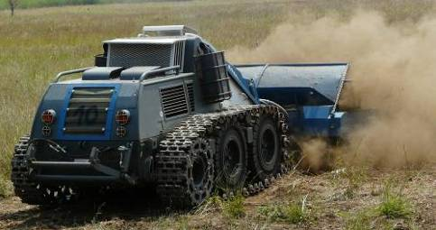
Remotely controlled machines that attempt to retain enough armouring to be able to detonate AT mines (like the machine shown below) should be avoided.
It is claimed that these machines can withstand an AT detonation under the flail with ‘repairable damage’. What is ‘repairable’ is questionable when repair may be more expensive than replacement. Also, while they may detonate AT mines with their flails, they may also detonate AT mines under their tracks, which will always result in catastrophic damage.
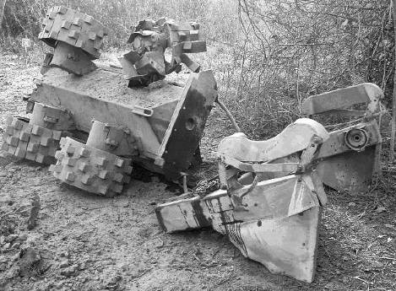
Because AT mines are designed to immobilise battle-tanks it is no surprise that the result of an AT blast underneath any demining machine is often catastrophic damage.
When the machine is relatively small, it will not only sustain extensive blast damage above the position of the detonation. It will also be thrown into the air and can be crushed by its own weight on landing.
 NOTE: Small demining machines must not be driven into areas where large pressure or movement sensitive explosive hazards are anticipated. They should not be used in areas where any movement sensitive armour piercing munitions (such as some submunitions) are anticipated.
The preferred vegetation cutting machine must be remotely controlled and have lightweight protection against AP mines and similarly sized hazards. It should be small enough to be easily transportable without a specialised vehicle. A mini-flail may be used in this mode when the rotation speed can be controlled to prevent rotation ‘overrun’. Small mulchers or flails can also be used on the end of a long-reach excavator arm with the machine standing on land that is known to be hazard free.

The real cost of demining machines
The purchase cost of a machine is only one part of the total cost of ownership. Other main costs are listed below.
- Delivery and importation to the country of use.
- A separate machine usually necessary to transport the demining machine to the working areas.
- Fuel consumption per hour of use.
- Service consumables including hydraulic oil and filters.
- Tools and specialist maintenance equipment.
- Replacement parts, including ground engaging chains, hammers and chisels, and their importation.
- Specialist staff to operate and maintain the machine.
- Cost of downtime while waiting for spares, consumables and specialist tools.
There may also be costs associated with storing the machine is a secure place.
The average cost per hour of use of a large machine must be determined before a machine is purchased. No machine should be bought unless it is certain to be used over a long enough period to justify the cost of purchase, maintenance and operator training. The funding that will be needed to cover the cost of the machine’s use over a protracted period should also be guaranteed.
When a large, purpose-designed demining machine is wanted, hiring the machine complete with operators, spare-parts, consumables and support staff may be the most economic choice. Any cost assessment should include the cost of training the operator(s) to use the machine in compliance with the procedures approved in this Chapter.
When considering using converted plant machinery, local purchase and alteration is usually the most economic and sustainable way to acquire the asset.
Whenever considering acquiring any remotely controlled equipment, purchase or hire from specialists should be preferred to local manufacture unless expertise in remote control equipment is readily available.

General rules for demining machines
The following are rules that must be applied when using any demining machine in a task area.
- Demining machines can only be deployed inside a potentially hazardous area where there is a manual demining team with a task supervisor who has overall responsibility for the management of the Task Release Plan. The task supervisor controls the mechanical team and may suspend the work of a demining machine at any time.
- No demining machine can be operated inside a potentially hazardous area unless the mechanical team leader is on site and in control of the mechanical operation.
- No demining machine can be operated inside a potentially hazardous area until the mechanical team leader has confirmed that all unauthorised people are at the required safety distance.
- No demining machine can be operated inside a potentially hazardous area unless a paramedic and ambulance are available at the task site. The paramedic should be no more than five minutes away from the machine.
- When the operator is assisted by observers, the operator must be aware of the observers’ positions and have reliable communication links with them for the entire time that the demining machine is in use.
- The demining machine operator and any observers must always have a reliable means of communication with the mechanical team leader while the machine is in use.
- All operators and observers must wear PPE unless suitably protected inside an MPV or behind an armoured shield. When inside an MPV or behind an armoured shield, they must have PPE with them for use in an emergency.
- When any demining machine is operated close to a road or an area where people may be present, the machine should be directed so that it faces away from those areas when it starts to process the ground or cut undergrowth. An effective means of preventing members of the public approaching should be in place.
- When any area preparation machine is first used in a region, its ability to survive the detonation of the anticipated devices without sustaining intolerable levels of damage should be tested in a controlled trial. The trials must involve the use of real devices in the same condition and the same environment as those in which it will be used. The demining machine should be used in the same way as it will be used in the working area. When it is not designed to detonate devices and fails to detonate any, its use should be approved. When it is designed to detonate devices and sustains significant damage when doing so, its use should be rejected.
- After using any area preparation tool, the machine must be moved to a designated inspection area to be checked as described in Part 2.5.1 of this Chapter.

Designated inspection area
At any task site where demining machines will be used inside a potentially hazardous area, there must be at least one designated inspection area close to the baseline that is large enough to allow free movement around the demining machines that may be used at that part of the task.
After processing the ground or cutting undergrowth in a potentially hazardous area, the demining machine must always be moved directly to the inspection area.
At the inspection area, a deminer in PPE must inspect the demining machine and its tool for any hazardous devices or parts of devices that may be on or attached to machine parts. When vision is obstructed by roots, earth or vegetation, the deminer may use a long handled heavy rake to cautiously remove the obstructions. The heavy rake is described in Chapter 6.
If any suspicious devices or parts of devices are discovered, the deminer must inform the mechanical team leader who must inform the task supervisor, requesting the presence of an EOD specialist deminer to deal with the device. All other staff must withdraw to the appropriate working distance while the EOD specialist deminer takes appropriate action. If the EOD specialist deminer decides to use a pulling procedure to remove the device from the machine, all staff must withdraw to the safety distance appropriate for the device.
When there is no hazard, the demining machine operator and mechanic can clean and carry out repairs or field maintenance tasks on the demining machine. Fuelling and general maintenance should not be conducted close to the working area, so the demining machine should be withdrawn. Any maintenance task that involves the changing of fluids must be conducted in an area where waste fluids can be captured and disposed of responsibly.

Terrain categories
Demining machine manufacturers sometimes specify the terrain over which their machine is designed to work, and the machine’s possible performance in those conditions. The defining features of the categories are varied and often inconsistent. In general, the machine’s anticipated performance should be estimated based on it achieving approximately 50% of what the manufacturer’s claim.
A ground processing machine’s ability to process the ground surface to any great depth is less important than its tendency to leave a level ground surface where previously the surface undulated. The required search depth at a task is always determined with reference to the original ground surface. When the use of a demining machine fills dips in the ground, it can bury hazards beneath the depth at which a metal-detector will reliably signal on them, which must be avoided.
For the purposes of internal assessment, obstacles are trees, wire, fences, trenches, ditches, ponds, buildings, vehicle wrecks, walls, buildings, and large rubbish piles. The following terrain categories may be used.
Category A terrain is either flat or with gentle slopes with dry topsoil. It has no rocks and stones. The vegetation has a maximum stem thickness of 3cm. There is no more than one obstacle in each 200 square metres. If these conditions are not met, the terrain should be classed as Category B, C or D. All demining machines can be used in category A terrain.
Category B terrain is either flat or has moderate slopes up to 15º. The vegetation has a maximum stem thickness of 10cm. There should be few rocks and stones. There can be obstructions in the working area but the gaps between them must be at least ten metres so that the machines can manoeuvre between them. If any of these conditions are not met, the terrain should be classed as Category C or D.
Category C terrain can be very uneven with slopes up to 20º. The ground can be wet and soft or rocky. The vegetation can be dense with bushes higher than 1.5 metres over up to 60% of area. There can be obstructions such as wire, fences, vehicle wrecks or large rubbish piles that may be close together. Heavy machines may become easily bogged-down in wet ground and may be unable to process the ground effectively while climbing slopes. In rocky ground, the wear on ground processing tools can make it uneconomic to try to maintain a processing depth.
Category D terrain can have slopes of more than 20º. The ground may have exposed bedrock or a rock covered surface. There may be dense trees, ditches, trenches and other obstructions. Progress in Category D terrain is usually very slow and expensive for any ground engaging machine and most can only work in small parts of the area.
When selecting or making demining machines, an ability to work in Category A and B terrain is generally the minimum requirement.

Demining machine deployment plan
Before a demining machine is used, the task supervisor should agree a tasking order with the mechanical team leader. It should include a map showing details of where the demining machine should be used. On accepting a tasking order, the mechanical team leader should make a machine deployment plan designed to achieve the required results. The mechanical team leader should plan the ground pattern over which to run the demining machine in order to ensure that the machine covers the entire area and can be easily seen while it works. The range of mechanical deployment patterns that can be worked depends partly on the machine being used.
The mechanical team leader must make a plan that is practical and will not result in injury or in unnecessary damage to the machine and its tools.
The task supervisor must ensure that the machine deployment plan meets the requirements of the tasking order. When machines cannot be used in the way that the task supervisor wants, the mechanical team leader should have the authority to restrict their use.
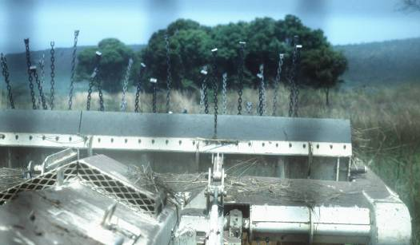
The tasking order and the machine deployment plan become a part of the Task Release Plan and copies should be kept in the Task Folder.

Limitations of flailing machines
Flail machines do not reliably detonate all the mines and explosive hazards in the ground that they hit. Even in ideal test conditions with newly laid pressure activated mines, 100% initiation cannot be guaranteed.
Some major limitations are listed below.
- When a flail machine is designed to apply pressure deep beneath the ground surface, the power requirements are so high that the weight of the machine can prevent it being able to both move forward and flail on upward slopes.
- On rocky ground or areas with shallow/exposed bedrock, the flail hammers cannot apply pressure uniformly and the loss of chains and hammers is common, so leaving gaps in the flailing pattern that may not be noticed immediately. Hazards have also been thrown aside, whichever way the flail rotates.
- Some anti-personnel mines are designed to be resistant to impact pressure and are unlikely to be initiated by any flail. Common examples are the PMN-2 and the VS-50 shown below.
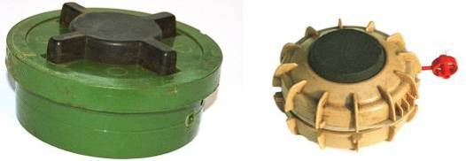
- AP fragmentation mines with pin-pull or tilt fuzes will not be reliably detonated by the flail. Exposed fuzes may be broken off but this cannot be assured.
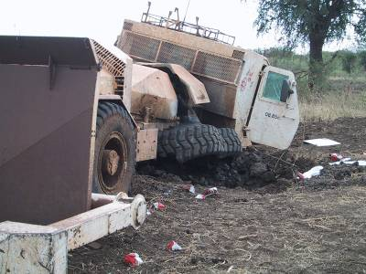
- If AT mines are anticipated in a working area, the
machine must be adjusted to apply sufficient
pressure to the possible depth of the hazards
because disrupting the ground above a deeply
buried AT mine can make it more likely to be
detonated by the pressure of the machine’s tracks
or wheels as the machine moves forward. The
photograph alongside shows a large flail that drove
over a mine that the flail had not initiated. The
integrity of the cab was compromised, the operator
injured and the machine very severely damaged.
- Almost all other explosive hazards will not be reliably initiated by flailing and some may be damaged in a way that increases risk for those who will have to Search & Clear the area.
 NOTE: Staff should not think that it is safe to walk in the tracks of any flail machine.
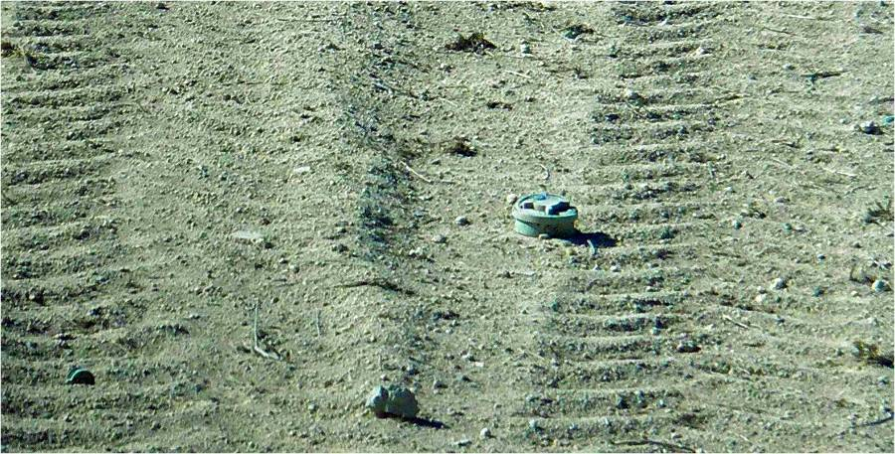
The photograph above shows a PMN-2 mine that was thrown aside by a large flail and left at the side of the demining machine.
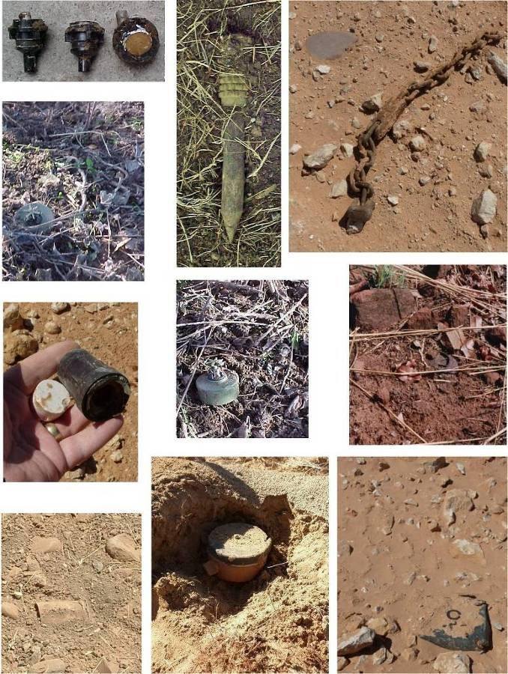

The photographs alongside show mines and hazardous mine fuzes that were found after the passage of large and small flail machines and (in several cases) after the land had been mistakenly released.
Most of these mines were clearly visible and many more hazards were found when the areas were later Searched & Cleared manually.

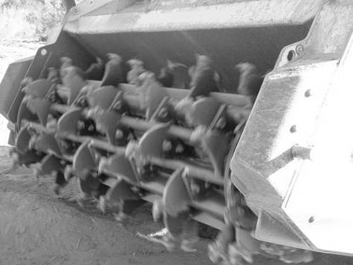
Limitations of ground tilling machines
As with flails, ground tilling machines cannot reliably detonate or expose all the mines and explosive hazards that are present. The photograph shows a small tiller with a cage rotor. Others have a drum rotor that is less likely to trap explosive hazards inside the mechanism.
The major limitations of ground tilling machines include those listed below.
- In soft ground, explosive hazards may be pushed deeper into the ground. Repeated passes with the tiller risk pushing the hazard deeper.
- In hard ground, devices may be thrown aside by tilling machines.
- In ground with large rocks, and/or shallow/exposed bedrock, the machine can only process to the depth of a rock across the entire rotor width, so a regular depth cannot be maintained.
- In rocky ground, damage to the cutting chisels (teeth) is rapid and can be very expensive.
- Small mines and the fuzes of larger mines can be missed by the tiller tool.
- AP fragmentation mines with pin-pull or tilt fuzes are unlikely to be detonated. Exposed fuzes may be broken off but this cannot be assured.
- AT mines initiated by crushing the top of the mine (the TM/N-46 shown below is a common example) may be left more sensitive by being partly crushed by the tiller.
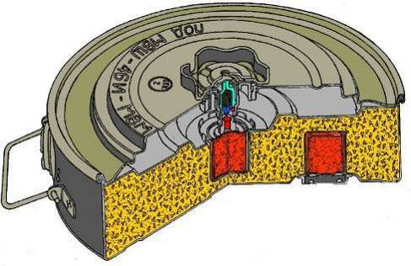
- If AT mines or similar hazards are anticipated in a working area, the machine must reliably process all of the ground to the possible depth of the hazards because disrupting the ground above a deeply buried AT mine can make it more likely to be detonated by the pressure of the machine’s tracks or wheels as the machine moves forward.
- Almost all explosive hazards other than pressure activated mines will not be initiated by the ground engaging tool and may be left damaged.
 NOTE: Staff must not walk on land processed by a ground tilling machine until follow up Search & Clearance has been conducted and the land declared ‘Cleared’, or the land has been Reduced by percentage clearance and declared ‘Presumed Clear, or the land has been declared NTE using the criteria detailed for land release in Chapter 3.

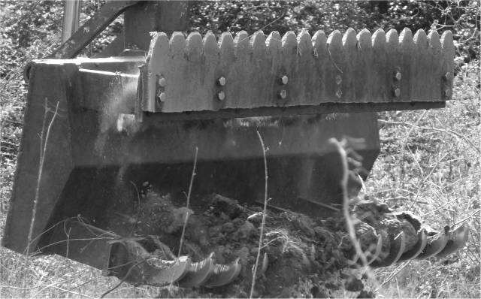
Limitations of raking machines
Raking machines are used to break the ground surface and remove vegetation and tree root systems. Generally adapted from a civil excavator machine, the ground engaging tool is a robust rake with heavy steel tines that may be sharpened on their leading edge. The tool uses a serrated blade to cut vegetation at or below the ground surface.
Some limitations are listed below.
- The raking tool can be designed to lift the anticipated hazards by spacing the rake tines so that hazards cannot fall in between. This can be effective in raising some hazards to the surface, but must not be relied upon.
- The raking machine can only be used to rake a wide-area when its tracks or wheels are able to withstand the detonation of any of the anticipated hazards at the task that may be initiated by its passage. If AT mines may be present, the wheels or tracks of the machine should not be permitted to move onto an area that has not been declared ‘Cleared’ or NTE so ‘Presumed Clear’ by the task supervisor.
- The operator’s cab of any converted excavator should be suitably armoured to withstand the detonation of any hazards that may be initiated as it works and this will increase its weight considerably.
- The raking tool may be unable to move large rocks.
 NOTE: Staff must not walk on land processed by a raking machine until follow up Search & Clearance has been conducted and the land declared ‘Cleared’, or the land has been Reduced by percentage clearance and declared ‘Presumed Clear, or the land has been declared NTE using the criteria detailed for land release in Chapter 3.

Checking the depth of ground processing
Demining machines that dig into the ground with flails, rakes or tillers leave behind ground that is mixed with air and the ground surface is higher than it was before the machine was used. When it is necessary to allow the depth of the ground processing to be reliably determined during QA, the depth of processing must be checked outside the working area before the demining machine is deployed.
The depth of ground processing must be checked in a safe area with ground conditions similar to those inside the working area.
The processing depth should be checked in the stages listed below.
- Set the tool to the desired depth settings.
- Process an area 10 metres long and the width of the tool using the ground processing tool moving forward at the speed which will be used inside the working area.
- Place a straight piece of wood or metal that is longer than the width of the ground processing tool across the processed ground and work it side to side so that it sinks into the disturbed ground and lies flat on the undisturbed ground that is on both sides of the processed ground. This piece of wood or metal is called the ‘level’.
- Measure the distance from the bottom of the level to the top of the disturbed ground it is lying across. This is the ‘ground-swell’ measurement and will be needed when checking performance inside the working area. It should be recorded on the daily work sheet.
- Remove the disturbed earth from a place alongside the level until undisturbed ground is found. The processed ground should be loose and easy to remove by hand.
- Measure the depth from the undisturbed ground to the bottom of the level. That is the processing depth at this place which should be recorded on the daily work sheet.
- Reposition the level and repeat the depth measurement in five places across the length and the width of the processed area.
The smallest of the five measurements is used to represent the reliable ground processing depth of that machine used at that speed in the ground conditions.
NOTE: If that depth is not enough to reliably strike or lift anticipated AT mines, even machines that are designed to survive AT mine detonations beneath the tool must not be driven in the area because the AT mines may detonate under the wheels or tracks causing severe damage.

Conducting QA on the depth of ground processing
When conducting QA in an area where the ground has been processed to a required depth, the following procedure should be used:
- Select an area where the ground is not level whenever possible.
- A breach must be cut using manual Search & Clearance procedures into the mechanically processed area.
- Always standing on Searched & Cleared ground, place a flat piece of wood or metal on the ground to use as a level.
- Dig the ground alongside the level until undisturbed ground is reached. The processed soil should be loose and easy to remove by hand.
- Measure the distance from the undisturbed ground to the bottom of the level. This distance minus the ‘ground-swell’ measurement that was taken before the machine was used is the depth of ground processing at that place.
Ground-swell measurement should have been recorded on the daily work sheet for the machine before it was used in the working area. If the ‘ground-swell’ measurement is not available, the depth of ground processing should be recorded as half of the measured depth (actual ‘ground-swell’ varies widely depending on the composition of the soil).
- The QA person should repeat this process randomly in at least five places along the breach. The smallest of the five measurements is taken to be the reliable ground processing depth that was achieved.

Using demining machines for area preparation
Any demining machine that removes vegetation or engages the ground is engaged in area preparation.
Any machine entering parts of the designated task area that are not declared ‘Cleared’ or ‘Presumed Clear ‘must be capable of surviving the detonation of any anticipated hazard that may be initiated by its presence without injury to its operator(s) and without being severely damaged.
Inside the task area, demining machines may be used for area preparation in one of the ways described below.
- A demining machine may be used to cut vegetation without engaging the ground.
- A demining machine may be used to break up the ground surface to a depth of not more than 5cm and may remove undergrowth at the same time.
- A demining machine may be used to mechanically process the ground to a recorded depth. The depth should be the maximum anticipated depth of large explosive hazards that are pressure or movement sensitive and that may damage the machine if they are not detonated or exposed by the ground processing implement.
- A demining machine may be used to remove obstructions from the working area (such as fallen trees or vehicle wrecks) in preparation for other assets to be used.
The use of BAC and BACS procedures after mechanical area preparation is only permitted when the relevant conditions for land release described in Chapter 3 apply.

Using machines to locate mined areas
Areas with functional pressure activated explosive hazards (such as anti personnel blast mines) may be located using any of the available ground processing assets as long as their use is not the only procedure applied to the area. When there may be large, deeply buried, pressure or movement sensitive explosive hazards present (such as AT mines), a ground engaging machine must process the ground to a depth that makes it probable that they would initiate or expose the large hazards. The depth of processing must be checked on land declared ‘Cleared’ or ‘Presumed Clear’ close to the working area immediately before deployment. The deployment method should ensure that the ground-processing tool remains visible whenever possible, so allowing variations in processing depth to be seen.
If the ground engaging tool rises and falls while it is being used, this indicates that the depth of processing is not constant and the machine should be withdrawn. This is because the large hazards are likely to be initiated under the demining machine’s wheels or tracks and cause extensive damage.
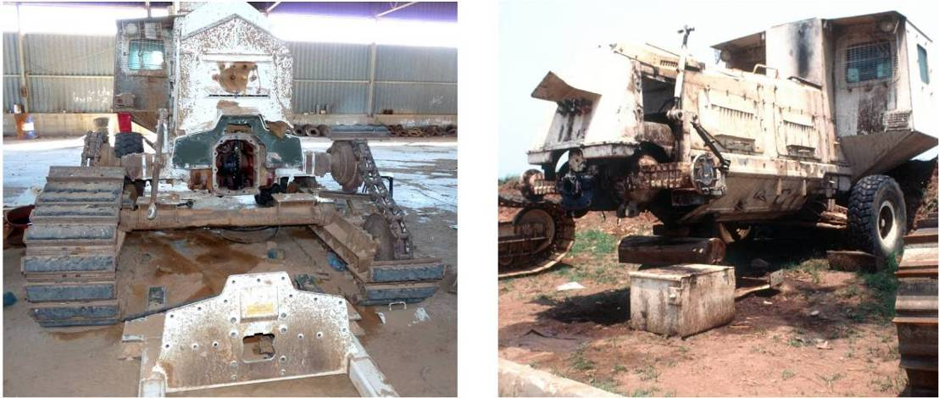
The large flails shown above were sold as being able to withstand AT mine blasts under their flail with limited damage. When the mines detonated under tracks, the damage was uneconomic to repair.
To try to locate an area with functional pressure activated anti-personnel mines with a demining machine, breaches should be made into the task area in the manner described below.
- Mark a baseline in a safe area using marking at five metre intervals. 1.2 metre pickets or flags may be used to increase the visibility of the marking.
- Move the demining machine to the baseline and position any observers that may be necessary.
- When a demining machine is remotely controlled, position the operator so that they will have a good view of the machine as it works. When possible, the operator should be inside an MPV.
- Position any observers at the correct distances and with appropriate protection.
- Remove the marking from the area of the baseline where the machine will work.
- The mechanical team leader must ensure that the only people inside the appropriate safety distance for the machine are appropriately protected mechanical team members.
- Demining machines that can enter the working area must start ground-processing before they cross the baseline and move forward processing the ground as they enter the area.
Demining machines that cannot enter the working area should be positioned on the safe side of the baseline with their ground processing tool hanging over the working area.
- The deployment pattern for the machine should allow all of the required area to be fully processed.
 NOTE: Areas processed by machines can never be considered safe. No one shall walk on ground prepared or processed by machines until it has been declared ‘Cleared’ or ‘Presumed Clear’ using the land release criteria described in Chapter 3.
When there are detonations, or devices are exposed, the procedures in Part 2.13 below should be followed. The Task Release Plan should be updated to ensure that the areas around any detonations or exposed devices are always Searched & Cleared.
All of the criteria for releasing land by Search & Clearance, area Reduction, area Verification, technical survey or area Cancellation are described in Chapter 3, Part 4.
In areas where there are no detonations or discovered devices during breaching, the demining machine may be used to process the entire area. The task supervisor can then consider applying the criteria for area Reduction listed in Chapter 3, Part 4.2, which will always involve Search & Clearance of some of the area because the failure of a machine to initiate a hazard is only an indication of the presence of explosive hazards on the land.

Using machines for area verification
When the Task Assessment or a revised Task Release Plan conclude that a part of a task area has No Threat Evidence (NTE), the area can sometimes be Cancelled without any demining procedures being used. The Cancellation criteria described in Chapter 3 must be applied. However, even when those criteria would allow Cancellation, the client or end-user must agree. To increase confidence that there is no need to conduct Search & Clearance over an area, it may be necessary to ‘Verify’ this decision by processing the area mechanically. This removes all vegetation and may make the end-users of the land more confident that the decision to release land as ‘Presumed Clear’ is correct.
The criteria for applying area Verification procedures are described in Chapter 3, Part 4.3.

Mechanical demining teams
The requirements of demining machines vary and the staff in a mechanical demining team may be changed when necessary.
The minimum mechanical team is generally:
- a mechanical team leader;
- Two machine operator/observers;
- a mechanic for the machine;
- a driver for transporting the machine;
- a deminer with PPE to be at the machine inspection area when required.
Additional observers to watch for devices that are thrown aside or exposed are needed with some demining machines, but are not always a requirement.
A manual demining team should be available to support the demining machine if required. When a manual demining team is assigned to the machine, their team leader should be controlled by the mechanical team leader. The mechanical team leader must always be controlled by the task supervisor.
When an MPV accompanies the machine as an observation or control platform, the MPV driver is a member of the mechanical team to which he/she is attached.
The duties and responsibilities of the mechanical demining team members are described in Chapter 1 of these SOPs.
When two or more mechanical demining teams are assigned to work at a task at the same time, the task supervisor must ensure that their work is integrated and issue appropriate tasking orders that allow for assets to work together efficiently.

Action when a demining machine detonates an explosive hazard
When a demining machine detonates or exposes an explosive hazard in a working area, the operator should withdraw the machine and inform the mechanical team leader.
- The demining machine must be withdrawn over the ground that has been processed and stopped inside the designated inspection area.
- After checking as described in Part 2.5.1 in this Chapter, the demining machine should be inspected for damage and repaired as required. When repair will take a significant time, the machine should be withdrawn to a service area so that PPE need not be worn.
- The mechanical team leader must record the approximate position of the detonation or exposed device on a map of the working area.
After inspection, an undamaged machine may return to work in an area that is generally at least five metres away from the detonation site. As a general rule, after one device has detonated the machine should not continue to work in the immediate area.
When the machine has been damaged and is unable to withdraw, the machine recovery procedures in Part 2.19 of this Chapter must be followed.
After any detonation that causes damage, the mechanical team leader must review the machine deployment plan. If the machine may be damaged by further detonations, it should not be used in that area.

Marking detonations and devices
When an entire area is to be processed using a machine, the position of any detonations or exposed devices must be marked at the time that they occur. This is usually done by stopping the machine and withdrawing it to an inspection area (see Part 2.5.1) before it is used to approach the area from another direction. The extent of the processed ground then marks the approximate position of the detonation.
When there is a need to continue ground processing past a point of detonation, the place where the detonation occurred must be recorded. This can sometimes be done by reference to fixed points close by, such as trees, but usually needs some kind of ground marking to be made. The preferred way to mark the site of a detonation is to use ‘safe area reference points’.
    - Marking detonations with safe area reference points
When there is a safe area on at least two sides of the area being prepared, the operator can place a marker in line with the detonation in both of the safe areas. A series of colour coded flag markers should be used when the position of more than one detonation is to be marked. The markers in the diagram below are shown as blue flags.
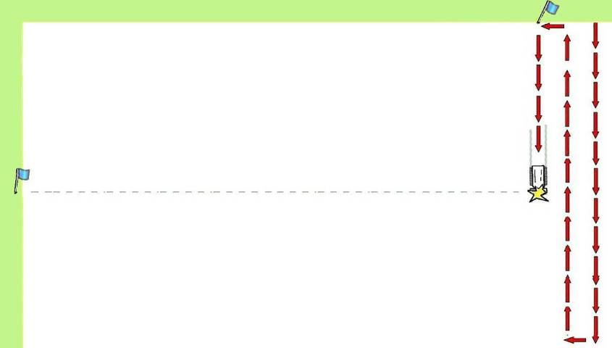
SHA
After the detonation and before being moved to the inspection area, the machine must be stopped and left standing while the observer or mechanical team leader (or a designated assistant) places flags in the two safe areas so that they line up with the place where the machine is standing. This can be accurate to within five metres.
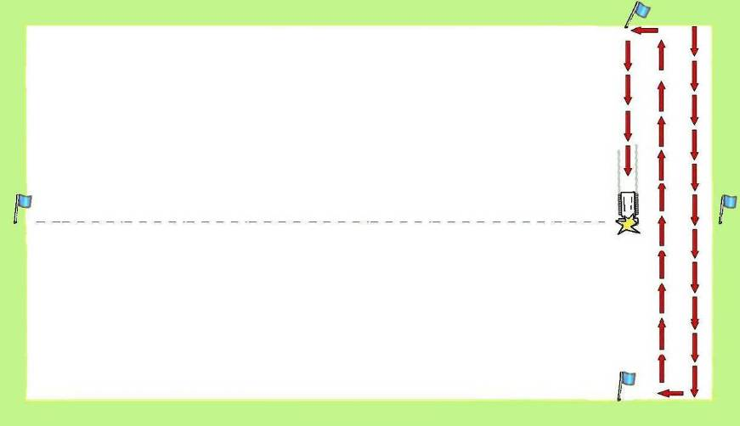
SHA
Accuracy can be improved by placing a third or fourth flag when safe areas exist, as shown in the diagram above. Although real working areas are never perfect rectangles, when there are safe areas all around an irregular area, a position can be marked by sighting from flag to flag with a good level of accuracy.
When the detonation has been marked, the machine should be moved to the inspection area (see Part 2.5.1) before work is continued.
    - Marking visible explosive hazards
If a device is visible to the operator or observer, the operator must not use the mechanical tool over it. The demining machine may be used to process the ground leading to the visible device but should be stopped at least five metres from the device. When the operator cannot see the device, he/she should be advised by an observer and stop the machine 10 metres away.
The operator should inform the mechanical team leader that a suspected device is visible in the working area. The demining machine should be withdrawn while the mechanical team leaders informs the task supervisor, asking for a manual demining Search & Clearance team and an EOD specialist deminer to be deployed.
When no immediate manual demining response is available, the demining machine can continue to be used in the area. It should leave the ground undisturbed in a radius of at least five metres in all directions around the suspected device.
Manual deminers or MDD assets must be used to Search & Clear a breach to the visible device. When they reach the device, the EOD specialist deminer should deal with it appropriately. After the device has been removed or destroyed, the demining machine can be returned to the area and used to process the ground that was missed when that is appropriate.

When a demining machine exposes an explosive hazard
When an explosive hazard is uncovered during area preparation, the operator should immediately inform the mechanical team leader. The mechanical team leader must record the approximate position of the exposed device on a map of the task.
The demining machine should be moved to work in an area at least five metres away from the uncovered device. When the operator cannot see the device, he/she should by guided by an observer and keep the machine 10 metres away.
When the demining machine has finished work or is working at the required mechanical safety distance, manual or MDD Search & Clearance assets may clear a safe breach at least 2 metres wide leading to the exposed device and an EOD specialist deminer should deal with it appropriately.

MEDEVAC procedures during machine use
If an accident involving a casualty occurs during the use of a demining machine, all staff must stop work, step back from the working area and wait for instructions. They must keep calm and quiet.
One of the following procedures should be followed.
Procedure 1: Machine stopped inside working area with a casualty on board
The mechanical team leader must order all work to stop and inform the task supervisor that there has been an accident with a casualty. The mechanical team leader should then either:
a) ask for immediate deminer assistance to Search & Clear an access breach from a known safe area to the demining machine, or
b) ask for an MPV to pick up the paramedic and two fully equipped manual deminers to transport them close to the casualty.
When an MPV is available the following response should be made.
  - The task supervisor should instruct the MPV driver to drive the machine to the mechanical team leader and follow his/her instructions. The task supervisor should call the paramedic and tell the ambulance driver to move the vehicle close to the baseline nearest to the casualty. The paramedic and ambulance may already have responded.
  - The mechanical team leader should instruct a deminer to bring the stretcher close to the baseline.
  - When the MPV arrives, the mechanical team leader should ensure that the paramedic, stretcher and two fully equipped deminers are on board, then instruct the driver to drive into the working area and stop the MPV beside the damaged machine so that the paramedic can step across to the damaged machine. When this is not possible or too hazardous, the MPV should stop behind the damaged machine and the two deminers should Search & Clear a safe breach to allow the paramedic to reach the casualty. Appropriate marking must be used to mark the safe access.
  - The paramedic should stabilize the victim then ask for the deminers to help remove the casualty from the machine and carry him/her to the MPV. The stretcher should be used whenever possible. When all staff and equipment are on board the MPV, it should return to the safe area and the waiting ambulance.
Procedure two from Step 7 should then be followed.
When no MPV is available, the following variations should be made to the above.
- The task supervisor should make available all Search & Clearance assets that will make safe access to the machine as fast as possible.
- When safe access to the machine has been achieved, the paramedic should approach the machine and stabilize the casualty, then ask for two deminers with a stretcher to help remove the casualty from the machine and carry him/her to the safe area and the waiting ambulance.
Procedure 2: machine standing in safe area with the casualty on board
- The mechanical team leader should order all work to stop and inform the task supervisor that there has been an accident with a casualty.
- The task supervisor should call the paramedic and instruct the ambulance driver to move the vehicle close to the baseline nearest to the casualty. The paramedic and ambulance may already have responded. After liaising with the paramedic and ambulance, the task supervisor should notify the operations manager that there has been an accident and that more details will follow.
- The mechanical team leader should instruct the nearest two mechanical team members to go to the casualty and offer moral support and first aid. They should not attempt to move the casualty from inside the machine unless it is on fire.
- The mechanical team leader should instruct another team member to bring the stretcher to the side of the machine.
- When the paramedic arrives he/she will stabilize the casualty then ask the mechanical team members to help remove him/her from the machine and place him/her on the stretcher.
Generally, the mechanical team leader should go to the casualty after ensuring that the paramedic and ambulance are en-route to ensure that all staff are acting in a calm and controlled manner. All accidents are shocking events, and staff who cannot cope should be replaced by people who are less shocked.
- The paramedic should supervise the transfer of the casualty to the ambulance.
- The mechanical team leader should stay in contact with the task supervisor and keep him/her informed of all developments.
- The task supervisor must liaise with the ambulance driver and confirm the MEDEVAC route to the nearest hospital. The task supervisor should also arrange for an escort vehicle to accompany the ambulance with two staff that have a compatible blood group to that of the casualty. Compatible blood groups are listed in Chapter 13 of these SOPs.
- As soon as the casualty is inside the ambulance, the task supervisor should notify the hospital that a casualty is en-route, giving the casualty’s name, blood group and an initial assessment of the injuries. The task supervisor should stay in contact with the ambulance and its escort vehicle throughout their journey to hospital. When appropriate, he/she should telephone ahead to arrange fast transit through checkpoints and traffic bottlenecks.
- When the casualty has been removed, the accident site must not be disturbed. All staff should be withdrawn to the administration area, collecting their equipment in an orderly manner. The accident area must be closed off. If equipment is left at the accident site, the task supervisor should arrange for a guard to be placed if necessary.
- No work should be conducted at the task site until an accident investigation has been completed. Staff should be kept busy with maintenance tasks and kept informed about the condition of the casualty as it becomes known.
- When all other staff has left the area, the task supervisor should carry out an initial investigation of the circumstances surrounding the accident. When they are known, he/she must notify the operations manager and request a formal accident investigation team to be convened. Generally the task supervisor or mechanical team leader will be a member of that team.
Procedure 3: Machine moving inside the working area with the operator a casualty
- If the demining machine is moving inside the working area with the injured operator inside, the mechanical team leader should liaise with the task supervisor and send a transport vehicle or MPV to the perimeter of the working area where the machine will enter safe ground.
- When the machine enters safe ground, the rescue machine should move alongside it and allow an operator or mechanic to cross onto the machine and stop it. MEDEVAC procedures should start from the place where the machine stops.
- Procedure 2 above is then followed.
Procedure 4: Casualty outside the machine and in a safe area
- The mechanical team leader should order all work to stop and inform the task supervisor that there has been an accident with a casualty.
When the casualty is the operator who was remotely operating the machine, the mechanical team leader must instruct the second operator to shut the machine down.
As long as the casualty has not initiated an explosion personally, the nearest staff should be instructed to go to the casualty and offer moral support and first aid. If the casualty has personally initiated a device outside the working area, the mechanical team leader must inform the task supervisor and either ask for immediate deminer assistance to Search & Clear from a known safe area to the casualty, or ask for an MPV to pick up the paramedic and manual deminers to transport them close to the casualty and then Search and Clear a safe access breach to the casualty.
When the casualty is in a safe area, the mechanical team leader will generally go to the casualty after ensuring that the paramedic and ambulance are en-route.
- Procedure 2 above from Step 5 is then followed.
Following any accident in which a casualty is taken to hospital, the task supervisor must ensure that the casualty receives the appropriate medical care and personal support. The paramedic should stay with the casualty until the injuries have been assessed and the treatment needs are known. If the casualty must be transferred to another hospital for specialist care, the paramedic should accompany the casualty.

Initial accident investigation
The task supervisor should conduct an initial investigation immediately after the accident. During that investigation the accident site should be photographed but left undisturbed. The names of all staff present at the time and involved in the MEDEVAC must be noted and a brief description of events surrounding the accident compiled. Generally, formal interviews of witnesses should not be conducted until a formal accident investigation is conducted.
The task supervisor should compile the information into a brief report and submit it to the operations manager and the programme manager on the same day as the accident occurs. The programme manager should notify the casualty’s family, the insurance company and the NMAA.
In case of a fatal accident, the programme manager should ensure that the police are informed and that any police investigation is assisted by all staff.

Encountering wire obstructions
The greatest threat to any demining machine with rotating parts may not be damage by explosive devices. Fibrous roots, barbed-wire entanglements, cables and concealed metal or concrete obstructions can cause considerable damage to rotating parts and their bearings. If any such obstruction is encountered by any machine with a rotating tool, the machine should be withdrawn and any damage repaired before it is redeployed to avoid the obstruction. When barbed wire has become entangled in moving parts, it must be removed before the machine is used again. The wire can so obstruct movement that severe damage results. Roots, wire or cable can also worm along rotating parts and damage bearings.
Tree roots, wire and wire fencing are often found inside task areas. When the operator of any machine with a rotating tool that engages the ground sees wire, he/she must stop the rotation of the tool and raise it above the ground. If wire or fibrous roots may have become entangled in the rotating tool, the machine must be withdrawn and driven to the inspection area for the obstruction to be removed. Before the obstruction is removed, the machine must be inspected as described in Part 2.5.1 of this Chapter.
Depending on the tools available, the mechanical team leader may decide to deploy another tool to deliberately remove the wire from the working area. If this cannot be done, the area leading up to the wire must be processed using approved Search & Clearance procedures and the wire dragged out manually or by attaching it to a machine and pulling it free.
NOTE: Wire that has been dragged into a safe area should be inspected by deminers in PPE for any devices that may be entangled in it.
When no means of dealing with wire obstructions is immediately available, the machine may be redeployed to avoid the area where there is wire. When the obstruction is fibrous roots, the machine should not continue work in the area where roots are anticipated.
NOTE: Never use a mechanical tool with wire, cable or roots wrapped around rotating parts. Fibrous tree roots can be strong enough to break robust rotating parts.

If a machine catches fire inside the working area
The machine’s recommended cleaning and maintenance schedules should mean that it does not catch fire without an outside cause. The outside cause may be damage resulting from the detonation of an explosive hazard.
Under no circumstances should any staff enter an area that is not yet declared ‘Cleared’ or ‘Presumed Clear’ in order to extinguish a fire on a machine.
If a fire breaks out on a machine inside a hazardous area, the following procedure should be followed:
- The operator or observer noticing the fire must report the fire immediately. The mechanical team leader should take control of the situation.
- The mechanical team leader must notify the task supervisor and ensure that no other demining activity is conducted within 150 metres of the machine.
- If the machine is remotely operated, the operator should try to drive the machine out of the area where fire-fighting equipment can be safely used. If that is not possible, the operator must shut down the engine and the mechanical team leader should ask the task supervisor for an MPV to be made available.
- When the operator is inside the machine, he/she should switch off the engine and use the fire extinguishers to put out the fire.
- If the operator needs to evacuate the machine, an MPV should approach the machine to extract the operator urgently. The MPV should stop alongside the burning machine, close enough for the operator to step between machines without stepping on the ground.
After the evacuation of the operator, persons inside the MPV can try to extinguish the fire using equipment inside the MPV. They must not leave the MPV when doing so.
- When no MPV is available and the operator risks injury by staying with the machine, the operator must evacuate the machine. The task supervisor should arrange for deminers to Start a Search & Clearance breach towards the rear of the machine from the closest safe area.
- Wearing the PPE that is always inside the machine, the operator must climb over the machine to the back and step onto ground processed by the machine as it advanced. If mine cushions designed to spread the pressure of a person’s weight are available, the operator should take the mine cushions and drop them from the back of the machine, then step onto them.
- Taking care to look carefully for exposed hazards and avoid them, the operator should move 50m back towards the baseline and the safe area, then wait for the manual deminers Searching & Clearing a breach to reach him/her.
 NOTE: A burning machine is not as important as an employee. No one should put their life at risk to try to save the machine.
The task supervisor may direct manual deminers to continue Searching & Clearing an access breach to the machine when there is no risk of its fuel tank(s) exploding. Generally this means that any access route cannot be completed until the fire has burned out.

Recovering an immobile machine
If properly maintained, all demining machines should run reliably inside the task area. If problems occur, the machine should be driven to the inspection area whenever possible.
In the demining machine breaks down or is damaged so that it cannot move while it is inside the working area, all other work within 150 metres of the machine must be stopped. The mechanical team leader must assess the situation and liaise with the task supervisor to start the appropriate machine recovery procedures.
The mechanical team leader will already have a Machine Recovery Plan covering predictable situations. The Machine Recovery Plan will include using a recovery vehicle or Searching & Clearing an area around the machine to allow an assessment to be undertaken where it is.

Using a recovery vehicle
When a recovery vehicle is available, it should be used to tow the demining machine out of the working area to a designated inspection area. When the recovery vehicle is an MPV, it may be used to recover the vehicle without safe access being made at the discretion of the task supervisor.
When the recovery machine is not an MPV, approved Search & Clear procedures must be used to make safe access to the machine that is wide enough for the recovery vehicle to use. When the access route has been Searched & Cleared, the deminers must withdraw to the required working distance while the recovery vehicle is driven to the disabled machine and a towing cable attached. The person attaching the towing cable must wear PPE and must not walk on ground that has not been declared ‘Cleared’ or ‘Presumed Clear’ by the task supervisor.
The recovery vehicle should then return to the safe area towing the damaged machine to a designated inspection area. Before the machine is inspected for damage, it must be inspected for any devices as described in Part 2.5.1 of this Chapter.

Making safe access around the machine
When no recovery vehicle is available, an access route to the machine that is at least two metres wide should made using approved Search & Clearance procedures. The area Searched & Cleared area should extend to at least three metres on all sides of the machine and be marked using an approved marking system so that there is no confusion about which areas are safe.
When the access route and area surrounding the machine have been Searched & Cleared, the machine’s mechanic should approach it and assess the damage. The mechanic must wear PPE at all times while inside the task area. If the machine can be repaired where it is, and without getting under it, the repair should be conducted and the machine driven to the designated inspection area and inspected as described in Part 2.5.1 of this Chapter. If the machine cannot be repaired where it is, it should be made secure and left for later recovery using a recovery vehicle.
When the damaged machine is removed, the ground where it stood should be Searched & Cleared using approved procedures.
- Management of mechanical demining operations
By integrating mechanical demining with manual and MDD Search & Clearance procedures, the Task Release Plan should ensure that all parts of the task are appropriately processed in preparation for the release of the entire task area. The Task Release Plan should ensure efficiency in terms of safety, speed and cost.
Operational information about each demining machine should be collected during machine use and used to inform its future use.

Deployment limitations
When planning for demining machine use, the task supervisor must bear in mind the following limitations. With larger machines, these limitations may make the use of the machine impractical.
- The roads and bridges on which the machine will travel to the task.
- The maintenance and repair facilities available in the task area.
- The fuel and maintenance requirements of the machine.
- Possible damage inflicted to property or infrastructure by transporting or using the machine.
When planning the repair, maintenance and servicing of the machines, care must be taken to prevent contaminating ground and watercourse with fuel, oil or hydraulic fluids.

Mechanical tasking orders
Mechanical teams may be moved between task sites where demining is being conducted. When a mechanical team arrives at a task, the task supervisor should provide the mechanical team leader with tasking orders that include a detailed map showing the areas that must be processed, each of which should be given an area ID number.
The mechanical team leader should assess the various tasks and report back to the task supervisor if any of them are not appropriate for the deployment of the machine. The mechanical team leader has ultimate responsibility for the mechanical team and the machine, and should not agree to use the machine in areas where it will be unnecessarily damaged or where staff will be exposed to unnecessary risk.
The mechanical team leader should use the tasking order and a site assessment to compile a machine deployment plan that makes maximum use of the machine’s capabilities. The machine deployment plan should be approved by the task supervisor and a copy kept in the Task Folder.

Mechanical demining - site requirements
The task supervisor must ensure that all task requirements are in place and that all mechanical team leaders on site have received and understood their tasking orders before they start work in any potentially hazardous area.

The mechanical team leader must be satisfied that the following requirements are in place.
- Communication between the operator, mechanical team leader, observer(s) and the task supervisor must be tested and working before the demining machine can enter the working area. Work must stop if the communication system fails at any time.
- A paramedic and ambulance should be at a safe distance within five minutes drive from the working machine and ready to make an immediate response. Work must stop if the ambulance becomes unavailable at any time. The mechanical team leader must not start any mechanical demining until the MEDEVAC plan for the task has been approved by the task supervisor.
- A written machine recovery plan has been approved by the task supervisor.
- At least one dedicated machine inspection area must be established close to the baseline from which the demining machine(s) will work.
- All team members have the appropriate PPE and other protection that will be needed.
- Appropriate mechanical area marking using pickets, flags or stones must be available. See Chapter 5 in these SOPs.
- Before the demining machine enters the working area, the mechanical team leader must brief the team and any deminers that may have been attached about the work they will conduct.

Mechanical safety distances
Safety distances used when machines are processing the ground inside a potentially hazardous area are not the same as working distances between working deminers. This is because there is no intention to cause a detonation when conducting manual or MDD Search & Clearance procedures. Increased distances should be used with any demining machine that is designed (or known) to detonate devices as it works. When the table below is not appropriate, the safety distances appropriate for demolition tasks should be applied.
Description | Min. distance to working machine | Safety equipment | Other conditions that should apply
Control point | 200 metres | No PPE. | None.
Refuelling/maintenance point. | 200 metres | No PPE. | None.
Remote operator/observer. | 10 metres | Armoured shield or MPV. | Beside or behind working direction.
Operator/observer in open (anticipated AP mine threat). | 25 metres | Shelter with PPE. | Beside or behind working direction.
Operator/observer in open (anticipated AT mine threat). | 50 metres | Shelter with PPE. | Beside or behind working direction.
All other operational staff. | 150 metres | PPE (complete). | None.
MDD team. | 300 metres | Not appropriate. | Working MDD must not be disturbed by machine noise or activity.
Non-operational staff. | 200 metres | Not appropriate.
Inhabited buildings. | 250 metres | Inside / behind buildings. | All windows open.
Demining machines on the same site. | 100 metres

General safety measures
Each demining machine is used in a different way and can raise safety issues unique to that machine. These are covered for each machine when their use is described.
The following general safety principles for all demining machines apply.
- No person shall walk on any mechanically prepared/processed area until it has been Searched & Cleared using approved manual or MDD procedures or formally declared as having No Threat Evidence (NTE) so ‘Presumed Clear’ by the task supervisor.
- Demining machines should not be used to deliberately detonate or disrupt visible hazards or to process land where a pattern of explosive hazards is anticipated.
- When an unexpectedly large hazard is detonated or discovered during machine use, the use of the demining machine must stop until the mechanical team leader and the task supervisor have decided whether it is appropriate for the use of the machine to continue.
- When any demining machine that has been working in a potentially hazardous area is withdrawn, it must be inspected in a designated inspection area as described in Part 2.5.1 of this Chapter. This check must be conducted by staff wearing full PPE. Any hazardous device of part of a device that is discovered in/on the machine should only be approached by an EOD specialist deminer.
- When the operator is inside a machine, there must always be PPE, fire extinguishing equipment and a working communications system inside the cab with the operator.
- Operators and observers of remotely controlled machines must ensure maximum visibility while remaining at a distance, behind protection or inside an MPV.
- Whenever a machine detonates an explosive hazard, it should be withdrawn and inspected for damage in a designated inspection area. On arrival in the inspection area, the machine must be inspected as described in Part 2.5.1 of this Chapter.
- Any machine with damage to its ground-processing tool must be repaired before being used inside a potentially hazardous area.
- All demining machines must be cleaned and maintained in accordance with the manufacturer’s recommendations and internal requirements.

Mechanical reporting requirements
Mechanical task reporting requirements are described in Chapter 15 of these SOPs.

Demining machine documentation
Each demining machine should have the documents listed below with it at all times:
- manufacturer’s handbook;
- manufacturer’s operators manual;
- mechanical demining SOP; and
- machine Log Book.
The machine operator is responsible for the safekeeping of these documents and should report loss or damage immediately to the mechanical team leader.
All machines should have a machine Log Book that should be a loose leaf binder to which pages can be added. The following information must be entered into the machine Log Book daily:
- consumables used;
- spare parts used;
- breakdowns and problems;
- tasking orders; and
- machine deployment plans.
The machine Log Book should also include the:
- daily inspection and maintenance record;
- weekly inspection and maintenance record; and
- the monthly inspection and maintenance record.
These should be kept in accordance with the manufacturers recommendations. Copies of the inspection and maintenance records, tasking orders, and machine deployment plans should be sent to the operations office every week to ensure that a ‘back up’ copy is preserved.
- Using converted excavators
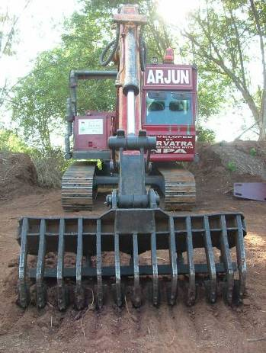
Converted excavating machinery that has been modified and appropriately armoured may be used. All converted excavators should have the features listed below.
- The cabin must be armoured to protect the operator against the effects of an AP fragmentation mine detonation or greater.
- All the cylinders, fuel tank and the hydraulic tank must be blast and fragmentation protected.
- Tools that can be attached should be designed to get into small areas where other machines cannot reach, such as trenches, ditches, canals, bridges, culverts, dry river banks, shallow water, around trees and around destroyed buildings and rubble.
- Tools should be changed using a ‘Quick Change’ device that makes it simple and fast to change the tools attached to the hydraulic arm.
An excavator with a tool that does not rotate can be used in areas with fibrous roots or wire obstructions without the constraints that apply to rotating tools.
The following limitations should be considered when planning to use of a converted excavator.
- The machine must not be driven over areas where large pressure or movement initiated devices (such as AT mines) are anticipated unless genuinely armoured against that threat. Armouring added after a machine’s manufacture does not normally protect the operator or the machine from large blasts.
- The machine should not be used in areas where the ground slopes more than 30° unless measures are taken to ensure its stability.
- The base machine is not designed for extended use processing wide areas of ground. While it may be used to do so, the operating times should comply with the recommended use in the manufacturer’s guidelines.
- The machine has no built-in recovery system. When using the machine in a potentially hazardous area, a recovery system capable of recovering the machine (plus the weight of its tool) should be at the task site.
When the machine is used inside the task area, protective shelters should be provided for observers and support staff whenever possible.
When planning deployment, the machine operator should be consulted about realistic fuel consumption and performance using the various tools.
The machine may work on steeply sloping ground as long as the base unit can be positioned in a stable manner. Depending on the tools used, it can process wet, hard or rocky ground. With the correct vegetation removal tools, it can remove mature vegetation.
The operating temperatures for the machine must be taken from the manufacturer’s handbook with allowances made for any reduction in air cooling made by the addition of armoured panels.
Depending on the tool, the excavator may be expected to expose or to detonate some explosive hazards. When used to deliberately expose devices, additional observers may be required to ensure that uncovered devices are seen.

Excavator tool attachments
Converted excavators may have a range of tools that can be attached to their hydraulic arms for performing varied procedures inside the task area as described below. The range and the size of each tool will depend on the power available to drive them. Generally, the larger the base machine the larger the working tools can be. The advantage of large tools has to be weighed against the disadvantage of increased weight (affecting transportation and work on soft ground), increased fuel consumption and the ability to access restricted areas (such as trenches).
Approved tools are:
- A rotary cutter attachment that concentrates the available power to drive a small rotating cutting tool that can be used to cut dense vegetation.
- A standard excavator bucket that can be used to dig out collapsed trenches, roadside ditches, or rubble from ruined buildings and spread out the material for subsequent search.
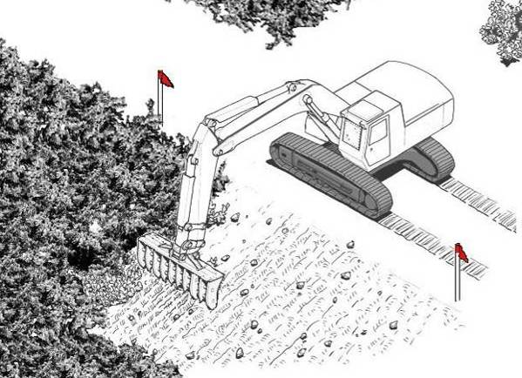
- A Sifting bucket which incorporates a grid mesh into a standard bucket so that loose soil can fall through the bucket while large objects remain. Its main use is for sifting soil that has been removed from hazardous areas. In soft ground, it can also be used to dig inside hazardous areas.
- The Arjun rake is a large-tined rake attachments designed to rake the ground to depths up to 30cm, break tree roots and lift concealed devices to the surface. Depending on the power available, it can effectively remove mature vegetation and fibrous roots from the working area, placing them to the rear for searching using manual or MDD procedures.
A drawing of the Arjun rake is shown alongside.

Constraints on use
If there is a risk of sensitive explosive hazards or armour piercing ordnance in a task area, the converted excavator should not be used unless appropriately armoured.

General operating rules
The tools that are to be used in a task should be positioned in the inspection area conveniently for tool exchange before the machine is used.
When tools are exchanged during work, the machine must be moved to the designated inspection area and inspected as described in Part 2.5.1 of this Chapter before the tool exchange is conducted.
In hard ground, the swing speed and digging depth of the tools should be decreased so that the load will not exceed the available power. Generally, a ground processing tool should be moved at a slow consistent speed through the ground. The operator must ensure that each cut made with the tool overlaps the previous cut.
The rotating vegetation cutter should be spinning at the maximum permitted revolutions before engaging the undergrowth. The tool should be regularly checked to ensure that no wire had become entangled. If wire has become entangled, the tool rotation must be stopped immediately and the machine must be driven to the designation inspection area and inspected as described in Part 2.5.1 of this Chapter before the wire is cut away.
The operator (and any observers) must always be watching for discovered devices and avoid detonating them when possible.
In dusty conditions, the operator should wait for any dust to settle before lowering the tool to the ground.

Performance in different terrain
The converted excavator can be used in all terrain categories but should not be used in wet ground in which the base machine may sink. Generally, if the mud and water rise to above half of the height of the track assembly, the machine should be immediately withdrawn.
The range of tools means that the converted excavator is able to work around or remove obstructions in the task area better than most other demining machines and the small size of the tools usually means that work can be conducted in restricted areas.
As long as the excavator itself is stable, the tool can be used on any slope. Generally the excavator body should not be used on a slope greater than 25° without taking appropriate stabilising measures.
The tools can be used in slow flowing water up to 30cm deep as long as no part of the hydraulic arm is submerged.

Using the rotary cutter
When the machine is appropriately protected against the anticipated hazards in a task area, the vegetation cutter can be used over a wide area. If any of the anticipated hazards could seriously incapacitate the machine or injure the operator, it can only be used with its base-unit standing in a safe area and its hydraulic arm extended over the working area.
The narrow and versatile position of the cutter can mean that it is possible to cut vegetation closer to obstacles than when using bigger machines. When the cutting tool is suitably robust, it may be used to engage the ground surface lightly to a depth of a few centimetres.

Using the excavation bucket
There are often small areas within a task where the most efficient method of Search & Clearance will be to lift soil or building rubble out of the potentially hazardous area and inspect it in a safe area. Examples are trenches or ditches and around damaged buildings.
The operator should follow the procedure detailed below.
- Position the tracks of the machine parallel to the baseline and at least a metre away from the baseline.
- Extend the hydraulic arm over the task area and dig into the ground to the required depth, then scoop backwards with an even sweep. The area excavated should be flat and free from loose soil.
- The operator should then swing the hydraulic arm over the safe area and release the excavated material in the soil inspection area. The bucket may be used to spread the load out evenly to a thickness of not more than 10cm.
- The operator should watch carefully for obvious explosive hazards as the bucket is emptied and spread out. If a suspicious item is seen, the machine must stop working until a manual demining team has Searched & Cleared up to the suspicious item and an EOD specialist deminer has dealt with it.
- The operator should then move the hydraulic arm over the task area and dig into the soil to the required depth again.
- This process is repeated until the soil inspection area is covered with loose earth not more than 10cm deep.
When something prevents excavation, such as an obstacle in the working area, the operator should position the hydraulic arm over the safe area while the observer places three white stones or pickets as a marker on the baseline.
When the machine has withdrawn or is working at its safety distance, the entire excavated ground must be Searched & Cleared using approved manual procedures as described in Part 4.4.1 below. When that has been completed, the area marked by white stones where the machine could not dig appropriately must be manually Searched and Cleared. After this has been done, the three stones of pickets should be removed and a white circle should be painted on the ground that was manually Searched & Cleared. This makes it easy to distinguish between obstacles waiting to be manually processed and those which have already been Searched & Cleared. White circles should be used to mark all small areas that have been manually Searched & Cleared in long linear excavation tasks.

Searching the soil in the inspection areas
A linear area free from metal should be prepared and marked to serve as the soil inspection area. When metal-detectors are used, this area should be declared metal free before it is used. When rakes are used in the Rake Excavation and Detection System (REDS), the area need not be metal free. The machine should spread the excavated soil out in inspection area.
- The heaps of soil should be dumped alongside each other and parallel to the baseline.
- The operator should lower the bucket and use the bucket teeth to spread the soil backwards so that it is spread evenly to a depth of not more than 10cm.
When the machine has withdrawn, or is working at its safety distance the manual demining team must search the access lanes and safe lanes over which the machine moved the bucket. Any spilled soil must be searched.
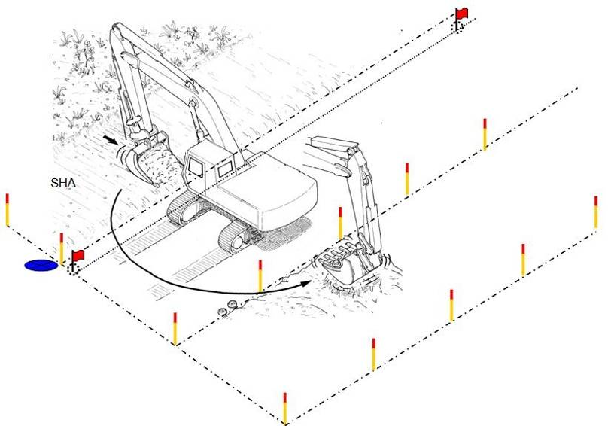
Inspection area
When the access lane has been checked, deminers using metal-detectors or rakes must manually search the soil inspection area using marked lanes and approved Search & Clearance procedures described in Chapter 6 of these SOPs.
NOTE: MDDs should not be used to check the soil inspection area unless it is left undisturbed for at least a week and the MDD coordinator is satisfied that the correct conditions apply and that the MDD sets have been appropriately prepared.
The soil is loose and there is no vegetation, so manual Search & Clearance progress can be very rapid using the REDS (which avoids delays associated with the presence of metal trash). Roots and rubbish should be removed and piled in a designated area for later burning or burial.
When appropriate, after a soil inspection area has been searched, the soil may be moved and the soil inspection area used again.

Ground preparation and vegetation cutting
Ground preparation may involve breaking up the ground surface (but not to a reliable depth) and vegetation removal. Vegetation should be cut from the top to the bottom by lowering the cutting tool onto it.
NOTE: Large trees are often valuable items and should not be cut unless the end user of the land agrees. There is rarely any chance of explosive hazards being underneath a large tree although they could be entangled in the tree’s root system.
The operator should follow this procedure:
- Lower the cutting tool to cut the vegetation down to a height of 40cm.
- If the cut vegetation obstructs a visual inspection of the terrain, it should be removed using a rake attachment without making contact with the ground.
- The ground should be inspected for explosive hazards and other obstacles such as wire, rocks and tree stumps. If explosive hazards are visible, the vegetation cutter should not cut lower in that place.
- When no explosive hazards are visible, vegetation should be cut down to a height of 10cm.
- If the cut vegetation obstructs a visual inspection of the terrain, it should be removed using a rake attachment without making contact with the ground.
- The ground must be inspected for explosive hazards and other obstacles.
- When no large pressure or movement sensitive hazards are anticipated in an area, the rotating tool can then be lowered to remove all vegetation and process the ground surface to a depth of less than 5cm.
This process is repeated until the vegetation is cut to the full extent of the hydraulic arm with the attached tool.
When the ground processing has reliably disturbed the ground surface, the cut vegetation may be removed using light rakes during manual demining procedures.

Moving obstacles with the rake or bucket
The excavator’s tools can be used to remove rocks, loose vegetation, fallen trees, branches, tree stumps and small vehicle wrecks, or to remove wire and fencing.
The operator must ensure that no explosive hazards are entangled with the items that are moved out of the task area. When there is any uncertainly, the area where the machine drops the obstructions must be marked and searched using approved manual Search & Clearance procedures.
The operator and a designated observer must look for objects that drop from the material being removed from the task area. The area over which the tool travels must be searched whenever items may have dropped from the obstacle being removed.

Using the sifting bucket
The sifting bucket is used to rake and sift ground inside the task area. It is not suitable for use in areas with significant vegetation or dense root structures.
The bucket is used to cut into the soil and then it is raised and shaken. Soil and small rocks drop through the grid structure leaving larger objects inside the bucket. When no objects remain inside the bucket after it has been shaken, the operator makes another cut with the bucket. When one of more objects remain inside the bucket, the operator swings the bucket over the inspection area, lowers the bucket and opens it to deposit the contents gently onto the ground.
The operator and observer should look for objects that drop from the material being removed from the task area to the inspection area. The area over which the tool travels should be searched whenever things have fallen. An observer should watch as the sifting bucket is emptied and if anything that may be an explosive hazards is seen, the machine must stop work while an EOD specialist deminer deals with the hazard.
When the machine is at the required safety distance or has stopped work, deminers using metal detectors or rakes should manually search the inspection area for devices that were not seen when the sifting bucket was emptied. They must use marked lanes and working distances as if it were any other Search & Clearance task. When rakes are used, all the soil must be raked through using lanes as described in Chapter 6, Part 9 of these SOPs. When metal-detectors are used, the entire area must be searched and left metal-free using the procedures described in Chapter 6, Part 7 of these SOPs.

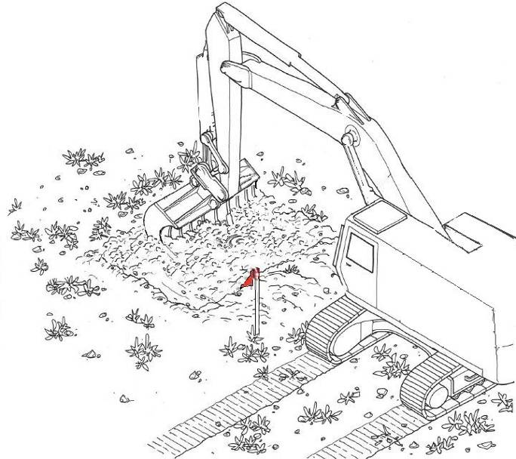
Using the Arjun rake
The Arjun rake is a tool that attaches to the
hydraulic arm of an excavator that cuts
vegetation and rakes the ground to
considerable depths. It is designed to
lift concealed devices to the surface.
The raking is used as a first pass over
an area that will later be processed using
manual demining Search & Clearance
procedures.
The raking will rip out light vegetation
and roots, making follow-up procedures
far easier. Depending on the tine spacing,
the raking can expose explosive hazards, and
may lift hazards from the ground.
The Arjun rake is generally used for Spot Tasks and road verges, but may be used to prepare breaches when its armouring provides appropriate protection against all of the explosive hazards anticipated at a task that could be initiated by its use.
Generally, the machine is positioned in a safe area alongside the area to be raked. The side of the safe area must be marked at regular intervals. Marking alongside the machine may be temporarily moved while it is working. For maximum stability, the machine should normally stand side on to the working area.
All persons except the operator must withdraw to the mechanical safety distance for the task before the hydraulic arm is moved over the task area. The operator should extend the hydraulic arm to its maximum working distance and position the rake tines at an approximately 30° angle to the ground. The tool should be lowered to the ground in that position.
The operator then uses the hydraulic arm to exert downward pressure at the same time as drawing the rake tines towards the machine. The rake digs into the ground and breaks up the soil.
This method may lift explosive hazards to the surface but should not be relied on to do so.
The area raked by the machine should not be walked over until it has been declared ‘Cleared’ or ‘Presumed Clear’ by the task supervisor applying the land release constraints described in Chapter 3.
- The MV-4 demining flail
The MV-4 demining flail is a tracked machine that is remotely controlled by an operator who is at a safe distance or behind protection. The operator and any observers should always have direct line of sight to the machine, preferably from the side so that obstructions may be seen in time to stop the machine.
The MV-4 is able to withstand the detonation of all AP mines including fragmentation mines. The detonation of a large device (such as an AT mine) under the flail should be expected to result in very severe damage (an example is shown on the left below). A detonation of an AT mine under the tracks may destroy the machine (as shown on the right below).
Extensive field experience gives confidence that the MV-4 is the best currently available mini-flail and that none of the larger remotely-controlled ‘midi’ flails is any more likely to survive a large blast with minimal damage.
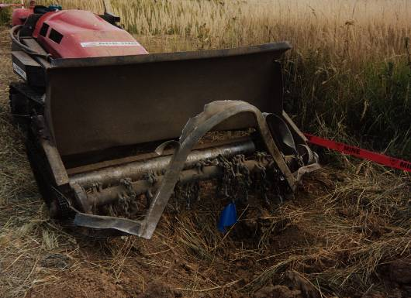
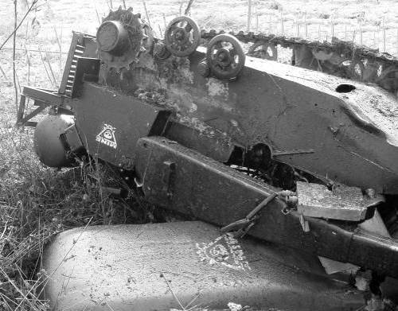
 NOTE: The risk to staff when the MV-4 flail is working is more than that associated with the kind of explosive device that may be initiated. Flail chains and hammers may break and can be thrown a long distance with great force.
The manufacturer reports that:
- the machine may process up to 2000m² per hour;
- the flail may process to a depth of 24cm;
- the machine is proven in operating temperatures up to 54°C and at 100% humidity;
- fuel consumption between 15 and 25 litres per hour; and
- the weight of the machine is 5.6 tonnes with all fuel and fluids.
The machine operator should be consulted about realistic fuel consumption and performance.

Constraints on using the MV-4
The general constraints listed below should be considered when planning to use the MV-4.
 NOTE: The MV-4 must not be used in areas where AT mines or large pressure or movement sensitive explosive hazards anticipated.
- The MV-4 should not be used to deliberately detonate more than one anti-personnel mine when making a breach into a hazardous area. Adjacent and overlapping breaches may be made. After any detonation, the machine should be withdrawn to the designated inspection area and inspected as described in Part 2.5.1 of this Chapter before any damage is repaired.
- In areas where pressure or movement sensitive explosive hazards mines are anticipated, caution must be taken when turning the machine. The tracks should not pass over ground that has not been processed.
- The MV-4 must not be used to cut trees over 15cm diameter or in areas where there are wire obstructions because both can cause unnecessary and expensive damage.
- The MV-4 must only be used with the greatest caution in areas where trenches, ravines, wells or ditches may not be seen by the operator.
- It can be a problem for the operator to maintain visual control of the machine. This can be overcome by protecting the MV-4 operator in an MPV when one is available. When an MPV is not available, the operator can be protected behind a mobile armour shield, behind a sand-bag shelter, or by distance and PPE. When appropriate, an observer may provide periodic aerial survey of the area to be processed using an SUA (see Chapter 10).
- The operator and any observers must be constantly looking for signs of chains and hammers being lost. If a chain or hammer is lost, the machine must be withdrawn to the designated inspection area and inspected as described in Part 2.5.1 of this Chapter before the missing parts are replaced. When the machine returns to the task area, the operator must ensure that the area flailed with missing chains/hammers is flailed again, generally starting from five metres before the loss was noticed.
- To ensure that the machine does not run into obstructions, the operator or an observer should be able to see at least one side of the ground processing tool whenever possible. In dusty conditions this can be impossible unless the machine is run against the prevailing wind.
- The operator of the machine should have been trained as a deminer and understand the procedures that will be used after the machine.

Terrain constraints for MV-4 deployment
The terrain selected as suitable for flailing with the MV-4 should be:
- level, or with a maximum slope of 25º;
- have sparse or medium vegetation (occasional trees or bushes with branches not more than 10cm in diameter); and
- have a minimum area of 50 x 50 metres.
When the flail will be used to process the ground surface this should be limited to 5cm depth or less and should be avoided whenever the area has surface rocks. On rocky terrain, the damage to chains and hammers can make the cost of breaking the ground surface prohibitive.
The following task and terrain conditions indicate an area that is not suitable for use of the MV-4:
- any area where large pressure or movement sensitive explosive devices are anticipated;
- any area where movement sensitive submunitions with an armour piercing capability are anticipated;
- wet or swampy ground with soft mud or water with a combined depth greater than 20cm;
- ground where reeds are growing;
- ground covered with dense vegetation with a stem diameter greater than 10cm;
- ground crossed by drainage canals, streams, trenches or ditches;
- ground crossed by walls, fences, barbed-wire or barriers, or beneath broken electrical cables;
- areas with many rocks, boulders, exposed bedrock or cliffs;
- areas where the ground surface is very uneven;
- areas where machine/vehicle wrecks or other obstructions may be concealed in vegetation; and
- urban areas or places with infrastructural assets.
The MV-4 may be used with caution by an experienced operator in some of the above areas, especially when vision is not inhibited by too much vegetation. In these cases it is probable that the demining machine would only be able to process parts of the area.
Processing the ground surface to a shallow depth can have considerable speed and safety advantages for the deminers who conduct Search & Clearance procedures afterwards. The task supervisor should weigh the advantages of deployment against the risk of damage to the machine when making the Task Release Plan.

Safety constraints
In addition to the safety procedures that apply to the use of all mechanical assets, the use of the MV-4 has the following safety constraint.
Machine safety distances must be observed whenever the MV-4 flail is rotating (whether inside or outside a potentially hazardous area) because of the risk of chains and hammers being thrown a considerable distance.

Observation posts
The MV-4 operator and/or observer(s) must be able to see the machine at all times when it is working. Whenever possible, the operator must be able to see the area the machine is approaching rather than the back of the machine. By watching the flail head from one side, the machine can be quickly stopped if it encounters an obstacle. If the machine is driven directly towards the operator or observer’s position, blast and fragmentation from any explosive hazard that is initiated may be directed towards the operator, so this should be avoided.
When an MPV is used as a mobile observation post, it should be moved whenever necessary for the operator to have the best view. When an observation post is in a fixed shelter or behind a shield, the mechanical team leader must work out the best position for the observation post and record when it should be moved as the work progresses.
Observation posts must not be moved inside the area processed by the MV-4 until it has been suitably followed up and declared ‘Cleared’ or ‘Presumed Clear’ by the task supervisor after applying the constraints required for land release (see Chapter 3).

Patterns of MV-4 deployment
When the surface of the ground in an area is to be processed by the MV-4 flail, the machine should be used in the patterns outlined below. Variations to these patterns are permitted and may be essential when an area includes obstacles that must be avoided. Whatever the variation, when adjacent MV-4 passes are made, they should always overlap by at least 30cm.

Overlap to ensure ground coverage
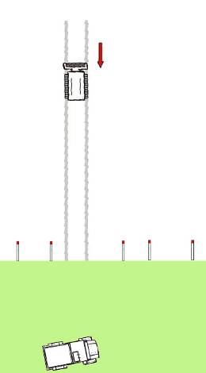
As the flail works, the flail head of the machine should overlap the previously processed ground by 30cm. Ground that has been processed before uses less power than it takes to process unbroken ground. Because the overlap does not use much time and fuel, the overlap should always be at least 30cm.
Diagram A
The MV-4 should not be used to try to process ground to a depth
of more than 5cm because this will use a lot of fuel and wear the flail heads to no advantage.
Reversing back along its tracks.

Straight line cuts
The MV-4 may be used to make straight line cuts into an area,
then reversed back out along the tracks it made as it went in.
This is shown in Diagram A alongside. These cuts should be no more than 50 metres long to ensure control when reversing.
Marking only moved aside where necessary.
When adjacent cuts are made, the second cut into the area should overlap the first by 30cm or more.
Baseline marking should be removed and replaced as the work progresses. The original line of the baseline must not be lost.
Overlapping cuts can be made to widen a breach or across a wide area, always starting with the flail head fully engaged with the ground before the machine crosses the baseline.
NOTE: When the flail makes a lot of dust, it can be impossible to see the machine. When there are obstructions in a dusty area, the machine should not be used.

Side-to-Side passes
The MV-4 can be run from the side across the working area, first passing the observer in one direction, then turning to pass in the opposite direction as shown in Diagram B. This allows a protected operator or observer to have a good view of the machine as it works and prevent the machine running into obstructions. It may not prevent the machine driving into ditches, wells of wire obstructions, of course.
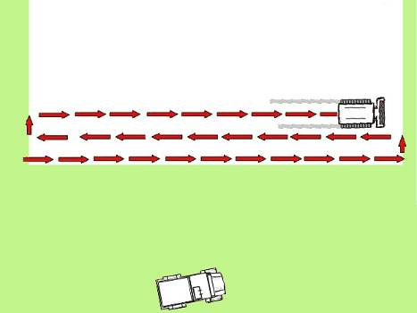
SHA
Start point
Operator inside MPV
Diagram B
In AP mine areas, the distance to the MPV may be as short as 10 metres because the operator or observer is protected.
If the operator or observer is behind an armoured shield or in a protected shelter, the minimum distance between the shield/shelter and the machine should be the safety distance for the greatest anticipated hazard that may be initiated by the use of the machine.

The snail system
When the operator has a good view, the MV-4 may be used to process an area by following its perimeter as shown in Diagram C below. The machine’s progress spirals around the task area a little like the spiral on a snail shell. The operator must move frequently to maintain line-of-sight of the machine while always remaining to its side or behind the machine. This method is most useful when the operator has an MPV to work from because the operator will need to move position frequently. In these circumstances the MPV driver should remain inside the cab with all doors and windows sealed while the MV-4 is working.
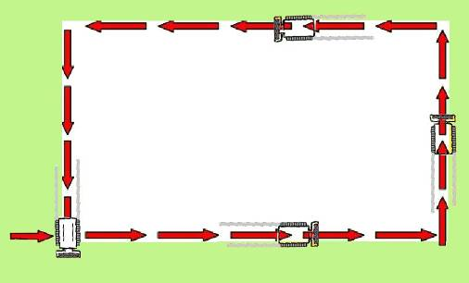
Diagram C
SHA
Start point
After one pass the operator stops and raises the flail, then turns off flail rotation and turns the MV-4 inside the safe area.
On the second pass, (shown in Diagram D), the inside edge of the first pass marks the new outer boundary. The operator should ensure that the flail-head has at least a 30cm overlap with the previously flailed area to be sure that no areas are missed.
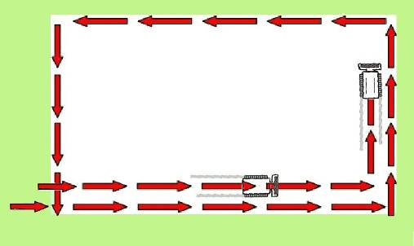
Diagram D
Second Start point
SHA
    - Covering the same area several times
When there is significant undergrowth, it may be decided to control the flail speed and make one pass to cut vegetation and a second pass to disrupt the ground surface.
It should never be necessary for the operator to try to get the flail to process the ground to the required search depth unless there are AT mines anticipated in the area and it has been decided to risk the flail tool rather than risk detonating an AT mine under the machine’s tracks. This is not recommended. If it is done, the flail must be able to process to the required depth in a single pass, which is only possible in soft ground.

Deploying the MV-4
This section describes the tasks for which the MV-4 may be deployed. As long as the safety constraints in this document are applied, other uses may be developed.
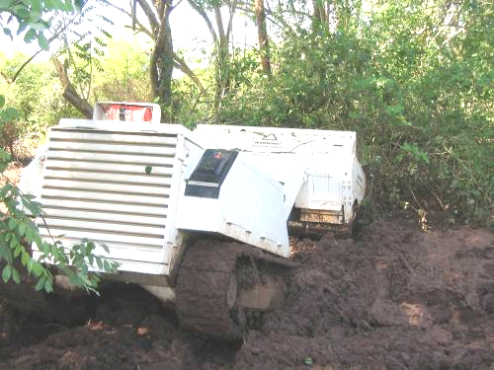
A manual demining team should be assigned to the mechanical demining team and should control area marking as well as Search & Clearance response in case of need. The deminers should work under the authority of the mechanical team leader.
The MV-4 shown here has driven into a wet ditch and dug itself in so that it needed to be towed out using another machine. A manual Search & Clearance team was used to gain safe access to the machine.

Preparing safe areas
The access lanes, administration areas and the start line outside the task area may be prepared using the MV-4 without manual follow up. Generally the machine may be used to prepare a wide area in which access lanes and safe area features will later be marked. The MV-4 may also be used to remove vegetation from observation areas behind the baseline from which the flail can be observed working inside the task area.
Even when no explosive hazards are anticipated, the minimum mechanical safety distances must be maintained during MV-4 operation because the flail itself poses a threat to people nearby and broken chains and hammers can fly a considerable distance. The operator should remain at least 15 metres behind or beside the machine wearing visor and body armour.
If any explosive hazards are detonated or discovered while the machine is being used to prepare safe areas, the machine should be withdrawn immediately. The operator must inform the mechanical team leader who will inform the task supervisor. The perimeter or the hazardous area must be revised to include the area that was believed to be a safe area.
When the MV-4 will need to use access-lanes to approach its working areas, those lanes should be made a minimum of 4 metres wide. After the access-lanes and safe area positions have been prepared, the machine should be withdrawn and deminers deployed to place safe area marking as shown on the sketch map in the Task Release Plan.

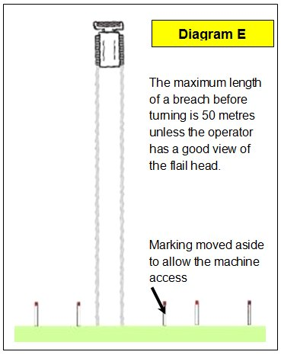
Preparing breaches
The MV-4 can be used to prepare breaches by cutting
the undergrowth and preparing the ground surface
starting from a baseline in a safe area and breaching
into the potentially hazardous area. Mechanical
breaches are usually made to try to identify HPA and
avoid having to Search & Clear more land than is
necessary. The machine is primarily used to prepare
the ground for rapid manual Search & Clearance but
may detonate some hazards as it works

The disadvantage of cutting a breach into areas with
high vegetation is that the flail head cannot be seen.
This means that the machine may hit an obstruction
that could have been avoided.
Breaches should not be cut into any task area where the anticipated hazards include large pressure or movement sensitive devices.
To maintain visible contact, breaches should not be longer than 50 metres before the machine is either reversed back to the baseline following the tracks it made on its way into the task area, or turned. Turns in breaches should only be made when the operator has good visual contact with the machine. When the operator is inside an MPV, the driver of the MPV should move the machine to the side as the MV-4 turns so that the operator is never directly in front of the flail while it works.
If the MV-4 detonates a device while working out from the baseline, the machine should be stopped and reversed to the safe lane. The length of the breach then marks the position of the device that exploded.
If the MV-4 detonates a device as it returns to the baseline, it should be stopped, reversed, and turned into the lane it processed on the way out from the baseline. It should return to the safe area along the previously processed lane and without the flail rotating. The operator must tell the mechanical team leader about the detonation, then move the machine to the designated inspection area where the machine must be inspected as described in Part 2.5.1 of this Chapter before checking for any damage.

Using the MV-4 to prepare road verges
Road verges should be prepared to 8.5 metres from the centre of the road unless otherwise specified in the Task Folder.
 NOTE: If there is a threat of large pressure or movement sensitive explosive hazards on the verge, the MV-4 must not be used.
The road itself should first be processed in a manner that allows it to be declared ‘Cleared’ or ‘Presumed Clear’ using the land release criteria detailed in Chapter 3. When the road is safe to use, the MV-4 is deployed in the following manner.
- The verge should be processed in 50 metre lengths after picket markers have been placed 50 metres apart on the verge to indicate the start and finish points.
- The 50 metre length of verge should be inspected for obstructions. If obstructions can be seen, white painted stones should be placed on the road alongside the obstructions to remind the operator of their position.
- Either the observer or the operator should be positioned so that they can see the flail head from the side.
- To provide an overlap with the area already processed or the area believed safe, the MV-4 should be positioned so that it can be driven off the road at an angle and begin processing the ground before it passes the start picket.
- The flail head should be brought up to a suitable rotation speed and lower to the required vegetation cutting or shallow ground processing depth, then the machine should be driven parallel to the road without disturbing the road surface unnecessarily.
- When the machine passes the end marker, it should be turned onto the road, its flail head raised and its rotation stopped.
- The machine should be driven back along the road to the start marker and positioned to prepare the area alongside and overlapping the area already prepared. When preferred, it may be reversed back along its tracks to the start point.
- Steps 5 to 8 should then be repeated until the ground has been prepared the required distance from the road.
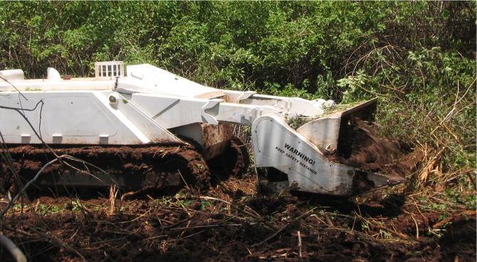
There are frequently obstructions on road verges. The operator/observer must keep a close watch for ditches, rocks, vehicle wrecks or other obstructions. When an obstruction is seen, the machine may process up to it without allowing the flail-chains to touch it. The flail-head should be raised and the machine reversed so that it can manoeuvre around the obstruction. When manoeuvring around the obstruction, the machine should be processing the surface of the ground it drives over.
A verge prepared in this way can increase the speed of manual Search & Clearance considerably but, when there is a lot of metal fragmentation in the area, the demining may still be slow and the use of REDS may be more efficient.

Using the MV-4 to cut vegetation
Cutting vegetation does not require the flail to process the ground.
As long as the speed of flail rotation can be controlled to prevent ‘over-run’, the MV-4 can be used to remove vegetation in areas where AP mines are anticipated. Vegetation removal without ground processing is necessary if the Task Release Plan involves using BAC or BACS in the area after the vegetation has been cut.
When a wide-area is to be prepared by the MV-4 flail cutting vegetation, this should be achieved by using the machine in the patterns approved above.
If any detonation occurs or hazards are discovered, the machine must be withdrawn immediately and the task supervisor must review the Task Release Plan urgently. If UXO or AXO that is not sensitive to movement or pressure is discovered, its position should be recorded and the machine may continue to cut vegetation over the rest of the area.
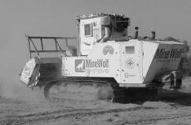
- Mine-Wolf
The Mine-Wolf has three main parts:
- A tracked manually operated or remote controlled vehicle;
- An armoured driver’s cabin; and
- A flail or tiller which attaches to the front of the machine.

The operator is protected by the cab armouring but the machine can also be configured for operation by remote control. The filtering and cooling elements are designed to allow the machine to withstand extreme heat and dusty conditions. The machine has a communications system, hydraulic winch, air-conditioning, and automatic fire-fighting system. A low-loader can be used for transporting it between task sites when road conditions allow this.
The ground processing width of the flail or tiller is approximately 2.8 metres.
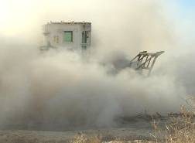

Mine-Wolf using the tiller in dusty conditions.
The tiller is designed to process the ground to a depth of up to 35cm depending on machine speed and soil conditions. An automatic depth control is designed to make ground penetration as consistent as possible but consistency is not possible over rocky ground.
As an alternative to the tiller, a flail with 72 chains with hammers can be attached. The flail can remove vegetation with trunk diameters up to 15cm.
The manufacturer reports that the machine has:
- cooling systems allowing operation in temperatures up to 52°C;
- an air-filtration system designed for conditions of extreme dust;
- a fuel tank that holds 440 litres and has an explosion prevention system;
- a fuel consumption between 35 and 45 litres per hour; and
- a hydraulic system using standard hydraulic fluid.
A realistic estimate of fuel use and operating conditions should be derived from the information recorded in the operator’s machine Log Book.

Constraints on using the Mine-Wolf
The following general constraints should be considered when planning to use the Mine-Wolf.
- The tiller may only be used when no AT mines containing more than 7.5kg TNT are expected.
- The flail may be used where AT mines containing up to 10kg TNT are expected.
NOTE: Damage should be anticipated after any detonation of a large hazard. That damage should be limited to the ground-engaging tool, but cumulative shock-wave damage to the main machine should also be expected. The use of the machine to deliberately detonate large explosive hazards must not be permitted.
- In dusty conditions the operator cannot see and must be guided by an observer using a radio.
- The machine has complex controls and can only be driven by a skilled operator.
- High vegetation areas cannot be processed by Mine-Wolf machines.
- The machine should not be used to detonate more than one hazard in an area. If a detonation is small, the machine may be used to make adjacent and overlapping breaches and so detonate more than one hazard when desirable.
- After any large detonation, the machine must be withdrawn to the designated inspection area and inspected as described in Part 2.5.1 of this Chapter before any damage is repaired.
- When pressure sensitive hazards are buried more deeply than the processing depth of the tiller or flail, they may not be detonated. The weight of the machine when its tracks pass over the mine may then detonate the hazard causing severe damage to the machine.
- In all AT mine areas, extreme care must be taken to ensure that the tracks do not pass over ground that has not been processed when turning the machine.
- The Mine-Wolf must not be used to cut trees over 15cm diameter or in areas where there is known to be wire obstructions.
- When the flail is used, the operator and any observers must be constantly looking for signs of chains being lost. If a chain is thrown out, the machine must be withdrawn to the designated inspection area and inspected as described in Part 2.5.1 of this Chapter before the missing chain(s) are replaced. When the machine returns to the task area, the operator should ensure that the area flailed with missing chains is flailed again, starting from at least 10 metres before the chain loss was noticed.
- The operator of the machine should have been trained as a deminer and understand the Search & Clearance procedures that will be used after the machine.

Terrain constraints for Mine-Wolf deployment
Terrain that is suitable for area preparation with the Mine-Wolf should be:
- level, or have a maximum slope of 20º, or 15° when the machine is to be driven across the slope;
- have light vegetation or no vegetation; and
- there should be a minimum of 500 square metres to be prepared.
The ground surface should have a covering of soil that is deeper than the required ground processing depth. Rocky terrain or areas with stone below a thin layer of soil may be processed, but the damage to chains or chisels may make the cost of doing this prohibitive and a regular depth will not be reliably maintained.
The following terrain conditions indicate an area that is not suitable for preparation using the Mine-Wolf:
- wet or swampy ground with soft mud or water with a combined depth greater than 30cm;
- ground where reeds are growing;
- ground covered with dense vegetation with a stem diameter greater than 10cm;
- ground crossed by drainage canals, streams, trenches or ditches;
- ground crossed by walls, fences, barbed-wire or barriers, or beneath broken electrical cables;
- areas with boulders, exposed bedrock or cliffs;
- areas where the ground surface is noticeably uneven;
- areas where machine/vehicle wrecks or other obstructions may be concealed in the vegetation;
- deep and loose sand; and
- urban areas or places with infrastructural assets.
The Mine-Wolf may be used with caution by an experienced operator in some of the above areas although it is probable that the ground processing would not maintain a constant depth and the machine would only be able to process part(s) of the area.
 NOTE: When the required depth is not maintained, BAC and BACS procedures must not be used as follow-up procedures. When the area must be declared ‘Cleared,’ it must be subject to manual Search & Clearance procedures after the use of the machine. When appropriate, a percentage of the area may be Searched & Cleared for land release as a Reduced area using the criteria detailed in Chapter 3.
Ground processing to a shallow or irregular depth can sometimes have considerable speed and safety advantages for the deminers conducting Search & Clearance after the machine. The task supervisor should weigh the advantages of deployment against the costs and the risk of damage to the machine when making the Task Release Plan.

Safety constraints
In addition to the safety procedures that apply to the use of all mechanical assets, the use of the Mine-Wolf has the following safety constraints:
- The Mine-Wolf should only leave the safe area with the rotating tiller or flail operating at a depth that gives confidence that it will not initiate large explosive hazards under its tracks.
- The safety overlap of the Mine-Wolf working lanes should never be less than 50cm, excluding the paths left by the skids on the sides of the tiller tool.
- Machine safety distances must be observed whenever the Mine-Wolf’s flail is spinning or the ground processing tool is engaged with the ground (whether inside or outside a possible hazardous area) because of the threat presented by throw-outs of chains and hammers, splintered rock, debris, or machine parts.
The Mine-Wolf must never be knowingly driven with its ground-engaging tool close to AT mines.
- The Mine-Wolf mechanical team leader must be involved in the preparation of the Task Release Plan and the machine deployment plan for the area where the Mine-Wolf will be used. That process ensures that the machine is not tasked to do anything for which it is unsuitable. The mechanical team leader must understand what is expected of the machine, the threats and associated risks, and how the mechanical processing fits into the deployment of other assets.
- Approved area marking using pickets or flags should be used. The general rules for the use of all machines detailed in Part 2 of this Chapter must be applied.

Mine-Wolf deployment patterns
The way that the Mine-Wolf may be used in a task area, using either the tiller or flail, is described below. These procedures are designed to ensure that the land is processed appropriately so that efficient follow up demining can occur.
Mechanical operations in the task area are constrained by limitations of terrain, fence, wire obstructions, rocks and trees. Suitable working areas will have been identified during the preparation of the Task Release Plan and the machine deployment plan.
There are three different procedures for area processing with the Mine-Wolf. Other procedures may be added as experience is gained.
- Area-Processing – ‘Sidestep System’
- Area-Processing – ‘Snail System’
- Area-Processing – ‘U-turn System’
The three systems are described in detail below.

Side-step deployment
When the area to be processed does not allow establishing a second safe area or a turning possibility the Side-step system should be used. This system is especially useful on roads or narrow areas next to obstructions.
- The demining machine starts from a baseline and begins processing the ground inside the known safe area. It is then driven straight forward into the task area processing the ground until one working lane is completed. The length of the lane should not generally be more than 50 metres except when processing roads.
- The operator raises the processing tool and reduces its rotation, then reverses the machine back over the same ground, following the tracks that the machine left as it entered. The machine is reversed until it is entirely behind the baseline.
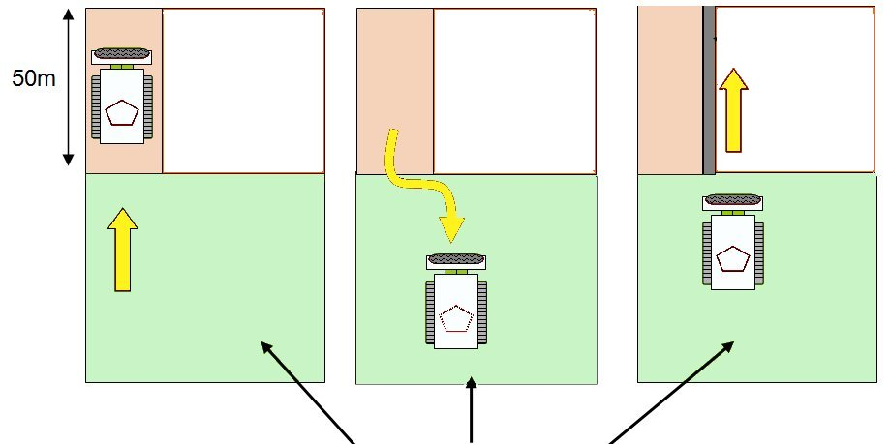
- The machine is moved sideways to start a new lane beside the processed lane. The new lane must overlap the previous lane by at least 50cm.
Step 1
Step 2
Step 3
Safe area
SHA
0.5 metre overlap

The ‘Sidestep system’ can also be used for area processing when appropriate.

Turning inside the task area
When it is possible, the Mine-Wolf can be used to make tight turns and so make angled breaches.
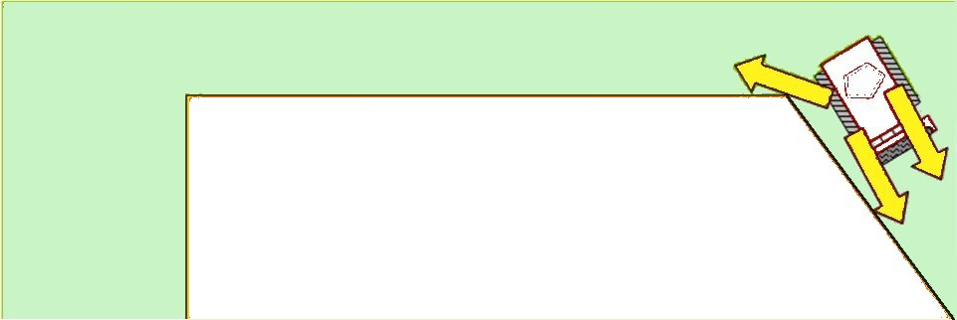
Safe area
SHA
Using the skid-steer system, it is possible to make fairly tight turns moving in forward and reverse without allowing the tracks to pass over unprocessed ground.
In areas where there is a risk of initiating large pressure or movement sensitive hazards such as AT mines, great care must be taken to avoid allowing the tracks to ever pass over unprocessed land.

The Snail system
The Snail system is generally the fastest and most cost efficient area processing procedure.
The machine is driven out from a safe area in a straight line into the area to be processed. The length of the working lane should not normally be longer than 50 metres.
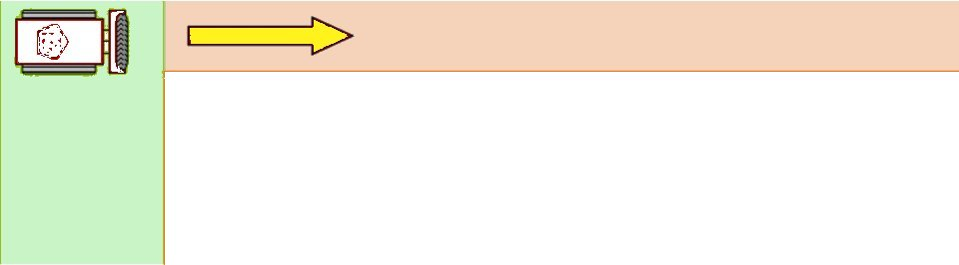
SHA
Safe area
To make a safe turn, the machine must reverse 15 metres and prepare short diagonal working lanes away from the first lane. The machine’s tracks should always be kept on area already processed as it works.
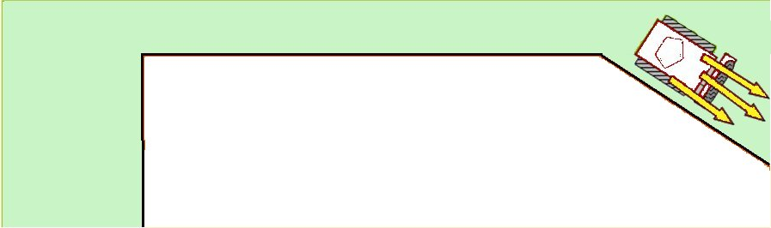
Safe area
SHA
After preparing a turning ‘triangle’ the machine turns and starts working on the second side of the area to be processed.
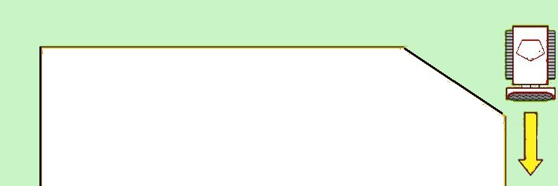
Safe area
SHA
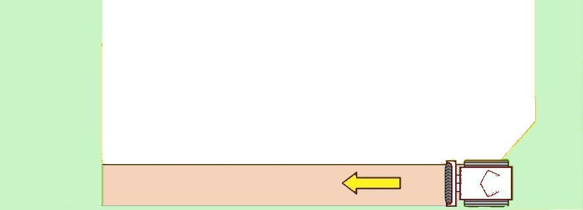
The turning process is repeated, and the second turn leads the Mine-Wolf back to the safe area.

After finishing a first complete lane around the ‘rectangle’ the Mine-Wolf is driven around inside that lane, with a 50cm overlap. The turns are always made with the tracks moving over processed land. The machine spirals over the area, a little like the spiral of a snail shell.
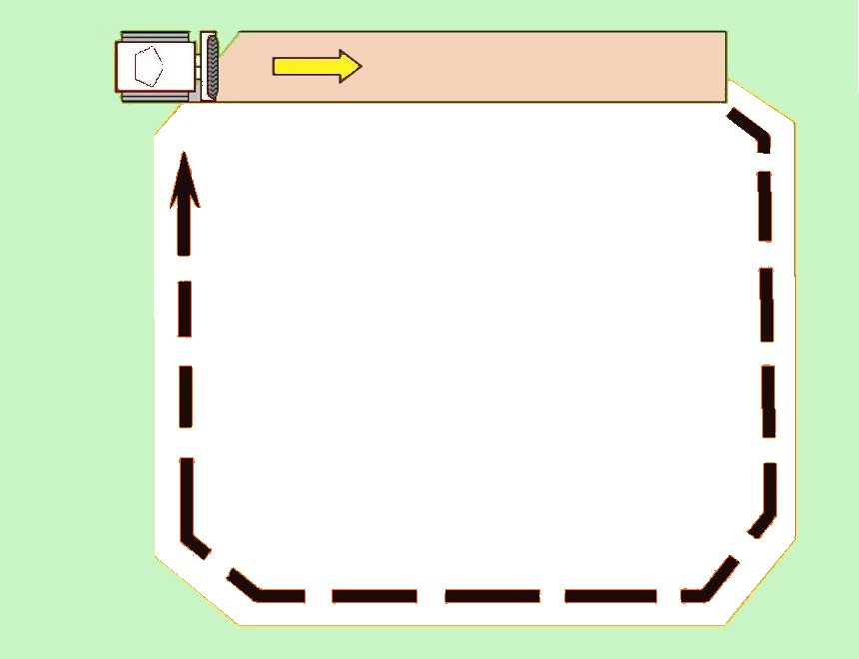
Safe area
SHA
Second pass with overlap
SHA gets smaller and smaller with each circuit of the Mine-Wolf
The spiral should not be used too strictly. When it is more efficient, the machine should be only used to process the long sides of the rectangle, and to simply turn around in the safe area at the ends.

The ‘U-Turn System’

At tasks with safe areas on both sides, the Mine-Wolf can start on one side, process across the SHA, and turn in the safe area on the other side.
The machine starts in the safe area. It is driven straight forward completing one pass until it reaches the safe area at the other side of the SHA.
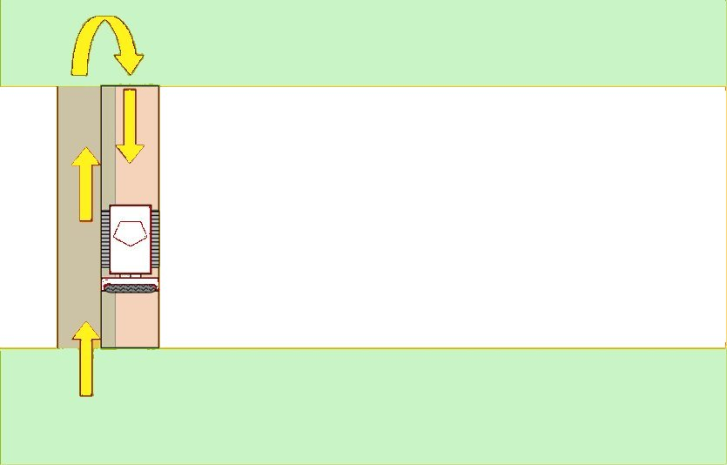

Safe area
Safe area
SHA
The length of each pass should not be longer then 100m.
The machine is turned in the safe area and returns to the starting area with an overlap of the ground processed (at least 50cm wide).

Mine-Wolf processing roads
If the road is surfaced with tar or broken tar, it should be Searched & Cleared using manual demining or MDD procedures. If an abandoned packed-earth road has dense vegetation over the road, the Mine-Wolf may not be used unless it can process both the vegetation and the ground in a single pass.
On a packed-earth road without dense vegetation, the Mine-Wolf can be used to process the ground in 100 metre sections to a 30cm depth. When the Mine-Wolf cannot achieve that depth in a single pass, it should not be used.
NOTE: If mines at greater than 30cm depth are anticipated on the road, the Mine-Wolf should not be used because there is a significant risk of the machine being severely damaged by detonating a deeply buried AT mine under its tracks.
The road should be processed using the side step system described in Part 6.2.1 of this Chapter. The Mine-Wolf should begin by processing two passes on both sides of the centre line. Processing 2.8 metre wide (with a 50cm) overlap means that an area 9.7 metres wide should be processed.
When long lengths are being processed, a turning area on one side of the road should be processed every 500 metres. At every 500m a 50x50m box should be Searched & Cleared using manual or MDD procedures to allow for other vehicles to safely turn.
When short sections of a road are impossible to work to an appropriate depth due to damage, ditches, culverts or bridges, the Mine-Wolf should be driven around that section of the road and leave it to be Searched & Cleared using manual or MDD procedures. Generally, the Mine-Wolf should process the ground away from the road as it passes the obstruction for its own protection.
When the Task Release Plan anticipates that the Mine-Wolf will work in advance of the manual and MDD follow-up, an MPV should be available to transport any Mine-Wolf casualty to the ambulance. The ambulance should be parked at the extent of the road that has been declared ‘Cleared’ or ‘Presumed Clear’ by the task supervisor.

Mine-Wolf processing verges
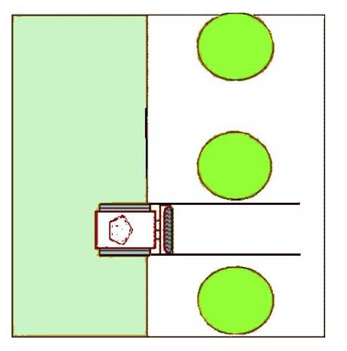
When processing road verges, the Mine-Wolf should process an area out to 4.8 metres from the centre line of the road unless otherwise required in the Task Folder. When verges must also be processed, that area should extend to 9.5 metres from the centre line on both sides, so processing a total width of 19 metres. The minimum is 18 metres, but the width of the Mine-Wolf tools may make 19 metres more appropriate.
Verges that have no obstructions may be processed using the side step system. When verges have many obstructions such as trees, boulders or vehicle wrecks, or when they have dense vegetation, other machines will be more suitable to use.
Road
Safe area
Tree
When the Mine-Wolf must be used to process verges in areas with obstructions, it should use the road as the safe area and cut out from the road moving between the obstacles. When appropriate it can be used to process an area on the other side of the obstacles to make turning easier and speed up the procedure.
Manual or MDD Search & Clearance procedures must be used to Search & Clear around the obstructions after the Mine-Wolf has moved to the machine safety distance. Search & Clearance must start on the road and search through the areas processed by the machine to reach and search and around the obstacles. Areas processed by the Mine-Wolf should not be presumed to be safe to walk on unless the areas have been formally declared to present NTE so be ‘Presumed Clear’ by the task supervisor.

Processing the same area several times
It should never be necessary process an area more than once with the Mine-Wolf’s tools. If the machine cannot process to a depth that makes it safe from the detonation of large pressure or movement sensitive hazards, it should not used at all. Also, processing an area more than once has an increased risk of leaving level ground where it was previously undulating and so burying some hazards beneath the detection depth of the metal-detectors used in Search & Clearance.
If an explosive hazard is not initiated by one pass of the machine there is no compelling reason why it should be detonated by any subsequent pass. Explosive hazards that are not pressure or movement sensitive, such as mortar bombs and grenades, are more likely to be damaged and rendered unsafe to handle by repeated passes than they are to be initiated.
The purpose of the machine is to prepare the area and to initiate some pressure activated hazards that may be there. If it does not achieve this in one pass, using it again would be a complete waste of time and money that did nothing to increase the probability that the area was free from explosive hazards.
- Mine Protected Vehicles (MPVs)
A Mine Protected Vehicle is a vehicle designed to protect the occupants from the worst effects of a mine blast. They are not Mine Proof Vehicles because some can be disabled by the smallest of mines simply bursting a tyre. Others can be severely damaged by a large mine but are designed to minimise consequences for the occupants.
There are many kinds of MPV, generally derived from vehicles originally designed for troop transport or combat use.
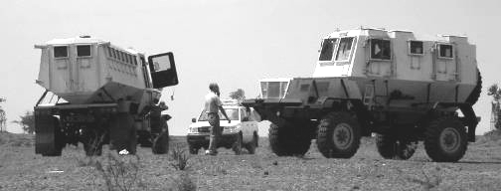
A genuine MPV was designed to be an MPV. It is not possible to convert an existing vehicle and render it genuinely mine protected by adding after market armouring. MPVs should be selected from reputable suppliers and constructed to a design that has been proven in use.
 NOTE: A Mine Protected Vehicle is not a Mine Proof Vehicle. It will be damaged in a large blast and the occupants may be injured.
The following safety measures must be enforced when using any MPV in a potentially hazardous area.
- When the MPV is moving inside a potentially hazardous area, all staff in the vehicle must be seated with their safety belts or harnesses fastened.
- When operating the vehicle in a potentially hazardous area, the doors and hatches on the vehicle must be securely closed.
- No staff may step from the vehicle into a potentially hazardous area for any reason. In the event of an emergency the area around the vehicle must be Searched & Cleared before it is walked on unless mine cushions (designed to spread the weight of a walker) are used.
- The cabin of the vehicle must always be free of loose objects (tools, equipment etc) that could cause injury in the event of a mine detonation at all times while the vehicle is inside a potentially hazardous area.
- When moving inside a potentially hazardous area, all MPVs must have effective communications and carry fire extinguishing equipment.

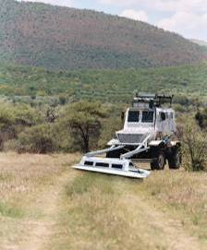
MPV with VMMD array
Mine Protected Vehicles may have a large metal-detector array mounted on the front or the back. These are called Vehicle Mounted Mine Detection systems (VMMDs). The metal-detector array covers a wide area and allows a rapid search of an area and it may reliably find explosive hazards that are large and metal-cased.
NOTE: No currently available VMMD arrays can reliably find plastic cased minimum-metal AT or AP mines at any depth, or find them at all when advancing at speed.
The method of operation should follow the manufacturer’s recommendations, but some general rules apply.
- The limitations of the system must be determined by independent specialists before the system is deployed.
- No MPV with a metal-detector array may be used in areas where plastic-cased mines are expected unless they have been proven effective in front of independent observers.
- If plastic cased mines may be in the area, the area must be searched again using MDD or manual deminers after the VMMD has searched.
- VMDD indications should be investigated using manual demining Search & Clearance procedures over an area of at least 3 metres on all sides of the investigation (a nine square metre area) unless the VMMD can reliably pinpoint a signal to a smaller area.
- When wide areas are searched and indications marked for some distance in front of manual follow-up, the follow-up should occur on the same day as the indication marking was placed. An indication map with GPS coordinates should be provided in the Tasking Order to the supervisor in charge of the manual Search & Clearance team.

Annex A: Risks associated with demining machines
IMAS 09.50 Mechanical demining was first issued in 2006 and last updated in 2011. This IMAS separates machines into those intended to detonate hazards, those made to prepare the ground, and those that are designed to detect hazards.
The IMAS states that when machines “may leave hazards within the agreed clearance depth, follow-up demining operations shall be carried out before the area is released as cleared”. Also that when a machine is used for Technical Survey, follow-up may not be required because the aim is not to clear the land. This is contradictory because to conduct any Technical Survey professionally and safely it is necessary to use efficient Search & Clearance procedures on parts of the land.
The primary goal of HMA is to leave safe land for end-users. Demining machines do not leave safe land but they can make the demining job safer by preparing the area. In some cases, they can also help to find areas that must be ‘Cleared’, but like any search method that is not 100% reliable, the land cannot be declared ‘Cleared’ unless the machine is followed up with reliable Search & Clearance methods over enough of the land to discover which parts of a task area need to be Searched & Cleared and which can be Reduced, Verified or Cancelled using the land release criteria given in Chapter 3. To use a lesser standard for Technical Survey is to put demining staff and end-users of the land at an entirely unnecessary, so an intolerable, risk.
Financial risks
The first financial risk that any demining organisation will face when acquiring a demining machine is the risk that its cost will be greater than expected. The cost of purchase, delivery and importation can be doubled by the cost of a transporter to move large machines around on roads (most tracked demining machines cannot be driven over asphalt or concrete roads). Moving a heavy machine over small roads can also cause damage to the road surface, culverts and bridges that must be repaired. Other costs include fuel, service and repair costs, plus downtime waiting for the delivery of specialist parts. Further cost in incurred because SOPs have to be developed and approved, operators and technicians trained, and a secure storage compound provided. The high costs involved in moving damaged demining machines to specialist repair centres in another country or bringing a team of specialist engineers to the machine can make repair uneconomic. The average or ‘average time between breakdowns’ is often thought important. In fact, because of the delays in getting parts and expertise to effect a repair, the ‘average time to effect a repair’ is more important because a machine that is awaiting repair is not a useful asset.
The total cost of ownership of a machine is always much more than its purchase cost. Before buying any machine, the operations office should be entirely confident that it will increase safety and efficiency in a way that is cost-efficient. Buying second-user commercial plant machinery to adapt for use in demining can reduce the financial risks involved in demining machine ownership in the following ways:
- second-user machines are often available at low cost;
- service parts and consumables are already available in-country at a reasonable price;
- experienced mechanics and operators are available;
- adapting the machine puts the end-users in control of its maintenance and development; and
- testing its limitations will result in an honest assessment of capabilities.
The greatest financial risk that the demining organisation runs when using the machine is if they presume that it can do more than it can and so put their own staff and the end-users of the land at unnecessary risk from explosive hazards. The only defence against this is to be able to demonstrate that the organisation has done everything reasonable to ensure that the land is free from explosive hazards before releasing it. This requires a detailed Quality Management procedure that follows the rational, humanitarian and practical criteria for land release detailed in Chapter 3.
Risk to end-users
The greatest risk that any HMA organisation runs is the risk of releasing land to end-users and telling them it is safe to use when it is not. The consequences in humanitarian terms, in reputational terms, and in terms of donor confidence can be severe.
Using any machine to process the ground in an area and calling that ‘Clearance’ would be a deliberate lie because every professional in HMA knows that no ground engaging machine can destroy all explosive hazards that may be present even if it passed over the land a dozen times. There are just too many kinds of ground and too many kinds of hazard in too varied a condition for this to ever be a valid claim – unless the land was free from explosive hazards before the machine was used. The lie would be unprofessional and would leave the organisation open to litigation in national and international courts. This could lead to extensive legal bills and punitive damages being awarded against the organisation. The consequences to the reputation and financial security of the organisation could lead to its closure, so from the organisational point of view, the consequences of taking this risk could not be more severe. The only sensible approach is to avoid the risk by not claiming that a machine can do more than it can be proven to do. There are circumstances in which the use of a machine can increase confidence that there is NTE in an area, but the use of the machine alone is not enough to Reduce an area as ‘Presumed Clear’ without a percentage of the land being searched my manual or MDD assets.
Risks to machine operators and deminers
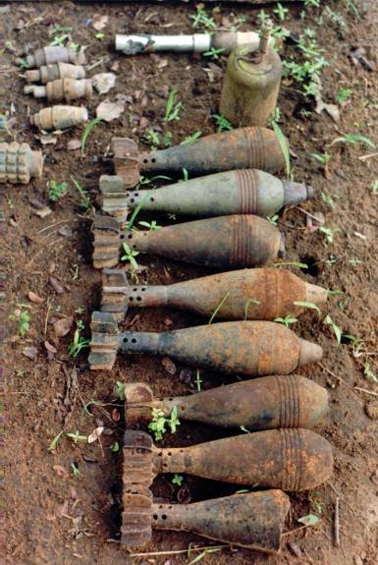
The accident record shows that the greatest risk to both operators and deminers is the assumption that the machine will detonate all sensitive devices so it is safe to walk behind it. Machines do not detonate all pressure sensitive hazards and both deminers and machine operators have been severely injured by waking on the land processed by a machine. This risk is addressed by prohibiting any movement on land processed by a machine until suitable follow-up has been conducted to prepare it for land release using the criteria given in Chapter 3.
The photograph on the right shows hazards found after the use of a large flail in an area where there were no pressure activated mines, so no detonations.
In areas where there are no AP mine hazards, machines are sometimes used to cut undergrowth before BAC or BACS search. If the machine engages with the ground while doing this there is a risk that the machine will leave munitions damaged and more hazardous or cover them so that they cannot be seen. These risks are avoided by ensuring that the machine’s tool does not engage the ground in areas where BAC or BACS will
be conducted after the machine.
Risks with converted excavator machines
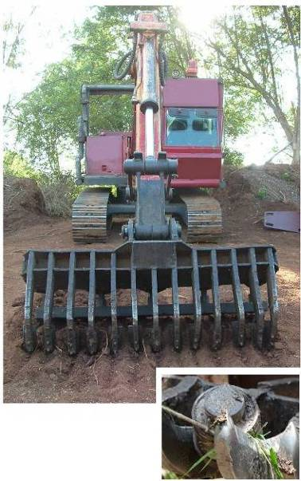
Converted excavators have been widely used in demining since 1997 in Afghanistan. There are not made as demining machines so there is a risk of them being severely damaged if they drive into a hazardous area and detonate a large explosive hazard beneath their tracks or wheels. Most can be easily protected against anti-personnel mine threats, but they have an operator inside and that person would be at intolerable risk if the machine initiated a large explosive hazard beneath it. When the excavator has a long-reach tool that is used to process the ground ahead of it in a way that exposes large devices and provides confidence that no large explosive hazards are in that area, it may then drive forward to process the next area. The area it stands on has not been ‘Cleared’ but it has been processed in a way that makes the risk to the operator tolerable as the rest of the area is prepared for efficient manual Search & Clearance.
The picture shows a raking back-hoe machine designed by Indian Army Engineers that has been widely used for area preparation in Sri Lanka and had proven unexpectedly good at exposing large and small mines. At one time 17 of these machines were in use and they exposed many AT and AP mines with the rake without any accidents.

Pictures courtesy of the Database of Demining Accidents (DDAS), www.ddasonline.com

